Risk Assessment Form
OSHC and Early Years settings – Incursions

This template must be reviewed and updated to reflect the risks relevant to the specific activity/event. This form must be completed before seeking authorisation for the incursion to occur and before seeking parent/legal guardian consent. This completed Risk Assessment Form must be available to parents on request.
Service Name:
Form completed by (name): |  |  |  |  |  |  |  | Signature and Date:
WHS Coordinator: |  |  |  |  |  |  |  | First aider/s:
Number of staff: |  |  |  |  | Max total no. of students and break down by age group: |  |  |  | Ratio:
NB. Ratio calculated with regard to risk assessment taking into account age of children and nature of activities.
NB Children requiring 1:1 support will be excluded from the ratio calculation, along with the adult supporting them.
Describe activity or event you are assessing:
Date of incursion: |  |  |  |  |  |  |  | Short description of incursion:
Incursion Provider name: |  |  |  |  |  |  |  | No. of Provider’s staff/attendees:
Incursion Provider’s staff/attendees names: |  |  |  |  |  |  |  | Signed agreement with incursion provider: | Yes/No
Incursion sequence
Time of Day |  |  |  | Describe whether a vehicle is accessing the site, equipment to be unloaded, set up and pack up of activity, start and finish time, pack up of activity, departure from service. Add rows for multiple activities.
Arrival at Service:
Set up activity:
Commence activity:
Conclude activity:
Pack up activity:
Depart Service:
Review the hazards, risks and controls described below and consider which are relevant to this incursion:
Step 1: Identify the hazard and assess the risk |  |  | Step 2: Reducing the risk - name the relevant controls that will reduce the risk |  |  |  |  |  | Step 3: Confirm the controls have been implemented and add additional controls or mark  ‘Not applicable’.
Selection of incursion/program provider
Suitability of incursion location  - Unsafe facilities giving rise to risks of injury and harm  - Inappropriate amenities that do not suit the specific requirements and capabilities of the group |  |  | - The suitability of the site for the activity (including sufficient space and room indoors where inflatables are being used).  - Additional safety equipment (eg soft fall mats as required).  - Educational outcomes to be achieved.  - Special needs including accessibility and medical considerations.
Use of external providers to deliver activities  - Lack of relevant qualifications and experience  - Inappropriate conduct towards children |  |  | - Seek confirmation from provider that instructors have the correct qualification and/or experience for their specific role/s.  - Require all providers to confirm they have current public liability insurance Certificate of Currency.  - Ensure all external providers have a risk management plan for the activity that has been provided to the Service.  - Ensure Third party Providers are screened in accordance with CESA processes. Refer OFFSITE_Third Party Providers (Child Protection) Letter and Form and Quick Help Guide _RRHAN, WWCC & EScreening
Activity related risks
Hazards relevant to specific sporting and adventure activity included in the incursion program  - Injury/death |  |  | - The Responsible Person has reviewed and considered the relevant activity instructions for Category 1 and Category 2 activities as defined in the Camps, Excursions, Sporting and Adventures Activities Procedure.
Water based and/or Aquatic related activities  - Insufficient supervision  - Drowning injury/death  - Trigger for epilepsy  - Child Protection risks |  |  | - Specific supervision of water play activities  - Specific consent must be obtained by the parent/legal guardian to permit their child to participate in aquatic related activities.  - The Responsible Person has reviewed and considered the relevant activity instructions for Swimming instruction – Category 1 and Category 2 including that specific supervisory ratios relevant to aquatic risks have been implemented.
Incursion provider vehicle and equipment  - Child run over/injured |  |  | - Appropriate plan for vehicle egress if entering Service site  - Adequate space for safe unloading of equipment
Specific Activity assessment
Use the activity assessment table below to identify and assess risks to the safety, health or wellbeing of children attending the incursion, and specify how these will be managed and minimised (National Regulations - regulation 101(1)).
A Risk Matrix is a useful tool to use during the activity assessment process as it helps in identifying the level of risk by looking at the likelihood that a negative event may occur and the severity of the consequence should it occur – refer Schedule 1 for a guide to rating risk.
This must include any risks associated with water-based activities.
Activity |  |  | Hazard identified |  |  | Risk Rating | Elimination/control measures |  | Who is responsible for the control measures |  | When is the control applied
Other
Any cultural or contextual considerations for specific students eg transitioning needs, sensory issues, social concerns etc
Other risks specific to the incursion/activity
APPROVAL
Acknowledgement: Safety risks have been identified for the listed incursion/activity with controls implemented to effectively manage risks to the health and safety of participating employees, volunteers, children and young people.
Confirmed by Director (name): |  | Signature and Date:
Authorised by Principal (name): |  | Signature and Date:
Risk assessment to be evaluated and reviewed by the Service after the incursion to record any learnings/improvements for next time:
Comments
Reviewed by (name and position): |  | Signature and Date:

Schedule 1 – Risk rating tools (taken from the ACEQA Risk Assessment and Management Tool)
When thinking about likelihood, the approved provider and service leaders should prioritise actions based on ensuring compliance with the minimum legislative standards, particularly those standards relating to safety, health and wellbeing of children.
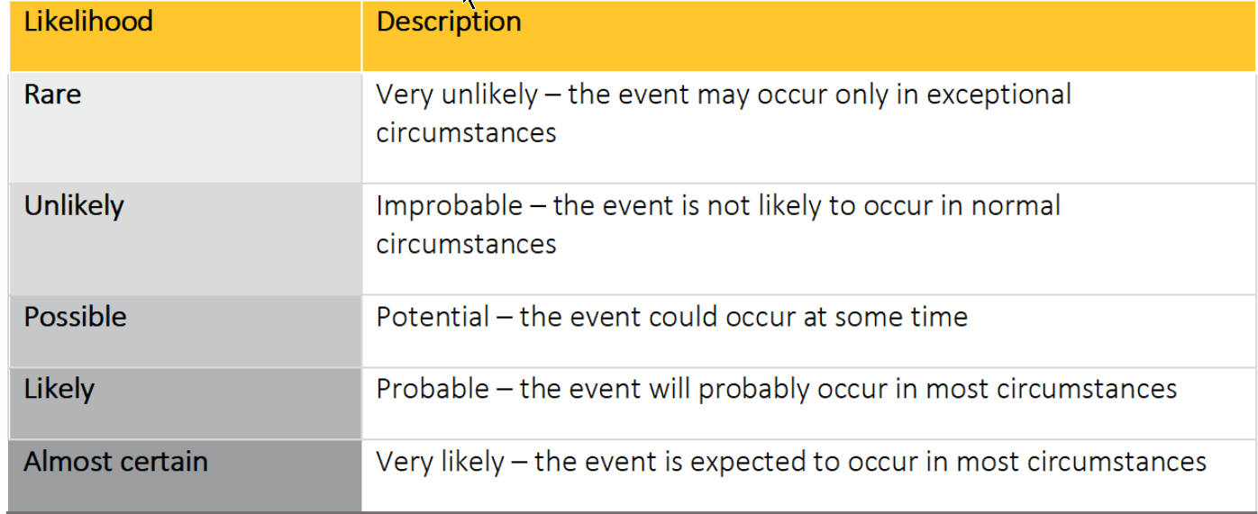
When analysing the consequences of a potential event occurring, it is important to consider the vulnerability of individuals who might be affected. For example, very young children or children with a disability may be particularly vulnerable as they are less able to act to protect their safety, health and wellbeing.
