TruSens 2000 / 3000 Air Purifiers  (Auto Operation with remote sensor) |  |  |  |  |  | SOP Number: |  | RA Number:
 |  |  |  |  |  | 95SOP |  | 113RA
DO NOT use / operate this equipment or complete the task unless you have been trained.
POTENTIAL RISKS: Skin Damage; Eye Damage, Electric Shock, Strains, Sprains, Lacerations, Pinch Points.

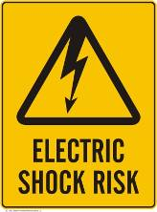 | 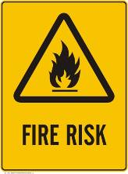 |  |  |  |  |  | 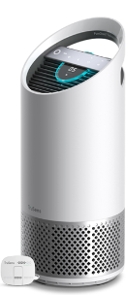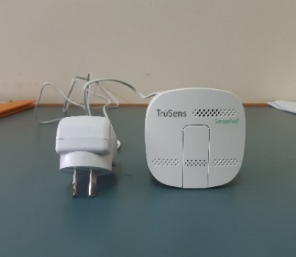

PRE-OPERATIONAL SAFETY
- Remove all packaging, including the filter bag, before use.
- Appliances that are obviously damaged must not be operated.
- This appliance must only be connected to a wall socket outlet matching the supply plug type and rating stated on the rating plate.
- Before switching on, check that the unit, remote sensor and power cords are not damaged.

OPERATIONAL SAFETY PRECAUTIONS
- Locate air purifier near the outlet wall socket and do not use extension cords.
- Plug the remote sensor (SensorPodTM) into a power outlet on the opposite side of the room, ensuring the air purifier is 3 – 15 metres apart and that are in the line-of-sight.
- Only use the purifier and SensorPod™ with the power cable provided.
- Switch the air purifier unit on by pressing the on/off button; the unit will take several seconds to boot up. The centre console will indicate the air quality – blue 0-50 = good; yellow 50 – 100 = moderate; red 100 – 500 = poor. Fan speed will automatically adjust.
- Ensure the UV on/off indicator is lit, this indicates that the UV air sterilisation function is operating.
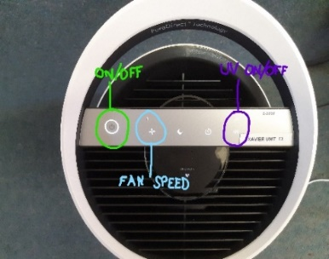
- Only clean this machine with a damp cloth, do not use solvents or bleach.
- Ensure appliance is always placed on firm level surface before operation.
- Do not block or obstruct the air intake or outlet vents.
- Do not insert fingers or other items into the air intake or outlet vents.
- When the air purifier is in standby mode the SensorPod is still transmitting a signal/data.
- At the end of the school day, switch the unit off, switch off the power outlets.

HOUSEKEEPING
- Switch off the machine.
- Leave the machine in a safe, clean and tidy state.
- Do not attempt to service or repair this product yourself
Date of last review: |  |  |  | Signature:

Acknowledgement: much of the information in this document has been sourced by the Department of Education & Children’s Services SA.

