Bandsaw |  |  |  |  |  | SOP Number: | RA Number:
 |  |  |  |  |  | 042SOP | 039RA
DO NOT use / operate / this equipment or complete the task unless you have been trained.
POTENTIAL RISKS: Foreign body in eyes; severe lacerations / cuts; Electric shock; crush injuries.
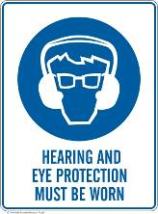 | 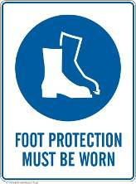 |  | 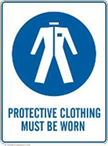 |  |   Rings & jewelly must not be worn | 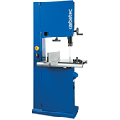

PRE-OPERATIONAL SAFETY
- Ensure no slip/trip hazards are present in workspaces and walkways.
- Locate and ensure you are familiar with the operation of the ON/OFF starter and E-Stop.
- Check that all guards are in position.
- Ensure push stick is available.
- Lower the blade guide and guard to full effect.
- Start the dust extraction unit before using the saw.
- Faulty equipment must not be used. Immediately report suspect machinery.

OPERATIONAL SAFETY CHECKS
- Never leave the machine running unattended.
- The work piece should be fed forward evenly and held firmly on the table to ensure effective control during cutting whilst keeping hands in a safe position.
- Use a push stick when feeding material past the blade.
- Do not force a wide blade on a cut of small radius. Use relief cuts when cutting sharp curves.
- Before making adjustments switch off the saw and bring the machine to a complete standstill.
- Stop the machine before attempting to back the work away from the blade.
- Stop the saw immediately if the blade develops a ‘click’. Report it to your Supervisor / Manager.

HOUSEKEEPING
- Switch off the machine.
- Leave the machine in a safe, clean and tidy state.

Date of last review: |  |  |  | Signature:

Acknowledgement much of the information in this document has been sourced by the Department of Education & Children’s Services SA.

