Blower Vacuum - Petrol |  |  |  |  |  | SOP Number: | RA Number:
 |  |  |  |  |  | 030SOP | 005RA
DO NOT use / operate this equipment or complete the task unless you have been trained.
POTENTIAL RISKS: Mechanical, Hazardous Chemicals, Hazardous Manual Tasks, Gravity, Noise, Fire, Extreme Temperatures
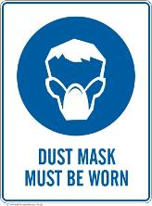 |  | 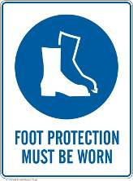 | 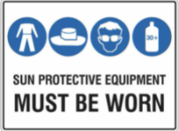 |  | 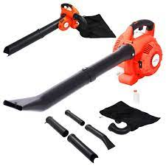

PRE-OPERATIONAL SAFETY
- Jewellery, loose clothing and hair to be secured so that it cannot be drawn into the air inlet.
- Check machine for loose/missing nuts, bolts and screws. Tighten and/or replace as needed.
- Inspect the parts of the mulching cutting head (where fitted).
- Ensure the debris bag (where fitted) is in sound condition and is properly fitted with no gaps.
- Ensure all guards are fitted, secure and functional.
- Faulty equipment must not be used. Immediately report suspect machinery.
- Ensure all other persons are clear of the immediate work area.
- Fuel the blower when cool and before starting work.

OPERATIONAL SAFETY PRECAUTIONS
- Ensure no person or animal is endangered when operating equipment.
- Adjust the shoulder harness as required to ensure it is in the most comfortable position.
- Keep a firm grip. Hold handles with fingers together encircling handles.
- Maintain a straight wrist position. Avoid using your wrist in a bent, extended or twisted position.
- Maintain footing and balance at all times. DO NOT stand on slippery, uneven or unstable surfaces. DO NOT work in odd positions or on ladders.
- Select the mode indicator to adjust the nozzle position for blow or vacuum.
- DO NOT direct the blower in the direction of other people.
- Take wind conditions into account. Avoid open doors and windows.
- Minimise dust by using blower at lower speeds.
- If the blower vacuum starts to vibrate abnormally, switch off and check immediately.
- Allow the engine and muffler to completely cool before refuelling or performing any maintenance.
- Switch off before removing or replacing the debris bag (where fitted).
- DO NOT place hands in bag when emptying. Sharp debris can cause injury.

HOUSEKEEPING
- Turn off fuel supply when work completed.
- Remove any foreign material from motor air inlet and nozzle
- Allow blower to fully cool before putting away.
Date of last review: |  |  |  | Signature:

Acknowledgement much of the information in this document has been sourced by the Department of Education & Children’s Services SA.

