Chainsaw - Petrol |  |  |  |  |  | SOP Number: |  | RA Number:
 |  |  |  |  |  | 067SOP |  | 069RA
DO NOT use / operate / this equipment or complete the task unless you have been trained.
POTENTIAL RISKS:
Cuts and lacerations / Hearing loss / Flying debris / Eye injuries / Entanglement / Crush injuries / Death
 | 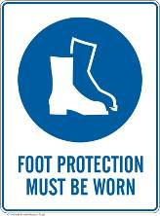 | 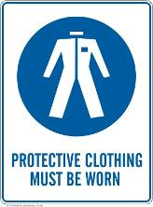 |  |  |  |  | 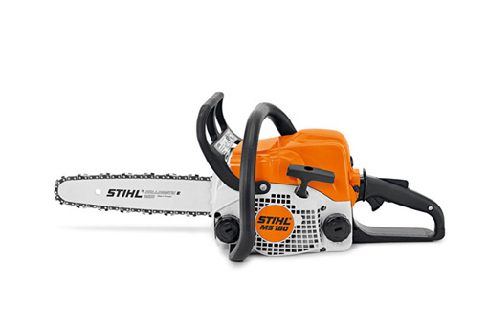

PRE-OPERATIONAL SAFETY
- Ensure the chainsaw is clean.
- Check for loose, worn or damaged parts. (Do not operate till repaired / replaced)
- Inspect fuel lines, carburettor for leaks. (Do not operate till repaired / replaced)
- Check effectiveness of chain brake and operating controls.
- Ensure safety guards and other safety features are secure and functioning)
- Ensure chain is sharp and correctly tensioned.
- Ensure you are in good physical condition to operate chainsaw.
- Ensure PPE is available and fits correctly.

OPERATIONAL SAFETY PRECAUTIONS
- Follow all safety precautions in the operator’s manual – improper use can cause serious or fatal injuries.
- Ensure area is clear of obstructions / other personnel.
- Start chainsaw resting on the ground.
- Maintain balance and secure footing when operating.
- Start cut with chainsaw at full speed and bumper is in contact with work piece.
- Be aware of the guide bar nose at all times when chain is in motion.
- Pay full attention at all times and be alert for movement of the work piece.
- Apply chain brake when chainsaw is at rest.
- Never use chainsaw over or above shoulder height.
- Allow chainsaw to cool before refuelling.

HOUSEKEEPING
- Clean chainsaw at completion of task.
- Sharpen saw chain as per manufacturer’s requirements.
- Service chainsaw as per manufacturer’s recommendations.
- Keep work area clean and tidy.
Date of last review: |  |  |  | Signature:

Acknowledgement much of the information in this document has been sourced by the Department of Education & Children’s Services SA.

