COOL ROOM |  |  |  |  |  | SOP Number: |  | RA Number:
 |  |  |  |  |  | 090SOP |  | 103RA
DO NOT use / operate / this equipment or complete the task unless you have been trained.
POTENTIAL RISKS: Locked In, Slips, trips and falls.
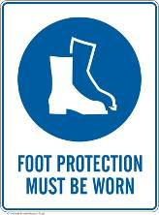 | 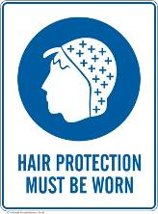 | 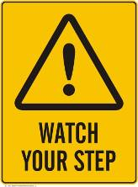 |  |  |  |  | 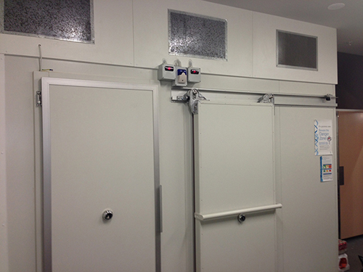

PRE-OPERATIONAL SAFETY
- Ensure all high risk foods are placed in cold storage areas and check the inside of the refrigerator or cool room using a thermometer It is vital that in a food business that all high risk foods and perishable foods are held at temperatures at or below 5ºC.

OPERATIONAL SAFETY PRECAUTIONS
- Refrigeration units should operate between 1ºC and 4ºC and it is important that the following steps are taken to ensure that these temperatures are maintained:
- - Cool hot food before refrigerating e.g. place in shallow containers so that it cools more quickly.
- - Keep opening and closing of fridge doors to a minimum.
- - Keep seals on refrigerator and cool room doors in good condition.
- - Store raw and cooked/ready to eat foods separately to eliminate the risk of cross contamination.
- - Store cooked and ready to eat foods above raw foods.
- - Foods stored in cool rooms should be placed on shelving at least 30cm above the floor.
- - Clearly label and date stored foods.
- - Ensure stored foods are rotated on a first in, first out basis.
- - Regularly check perishable products and discard any that are spoiled, contaminated or out-of-date.
- - Regularly clean the refrigeration units including cool rooms and fridges.
- - Do not store cans/tins in the refrigerator once they have been opened. Place contents in food grade containers.
- - Do not over crowd refrigerators and cool rooms with product.
- - Do not stack product in front of motors or fans.
- - Do not let ice build-up in the fridge. Defrost regularly.

HOUSEKEEPING
- Keep clean.
- Wipe up spills immediately
- Do no leave items on the floor
- If unit is not keeping correct temperature, contact Maintenance.
- Test Emergency light and bell on a regular basis.
Date of last review: |  |  |  | Signature:

Acknowledgement much of the information in this document has been sourced by the Department of Education & Children’s Services SA.

