Cut Off Saw |  |  |  |  |  | SOP Number: |  | RA Number:
 |  |  |  |  |  | 051SOP |  | 044RA
DO NOT use / operate / this equipment or complete the task unless you have been trained.
POTENTIAL RISKS: Moving, rotating and sharp parts; Dust and fumes; Electricity Pinch and crush; Eye injuries; Noise; Burns and hot ejected waste material

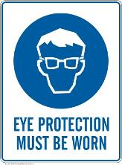 | 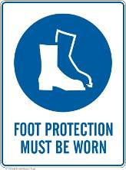 | 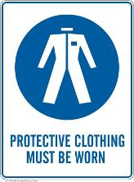 | 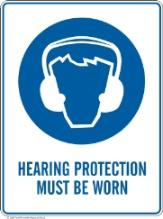 |  | 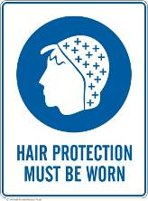 |  | 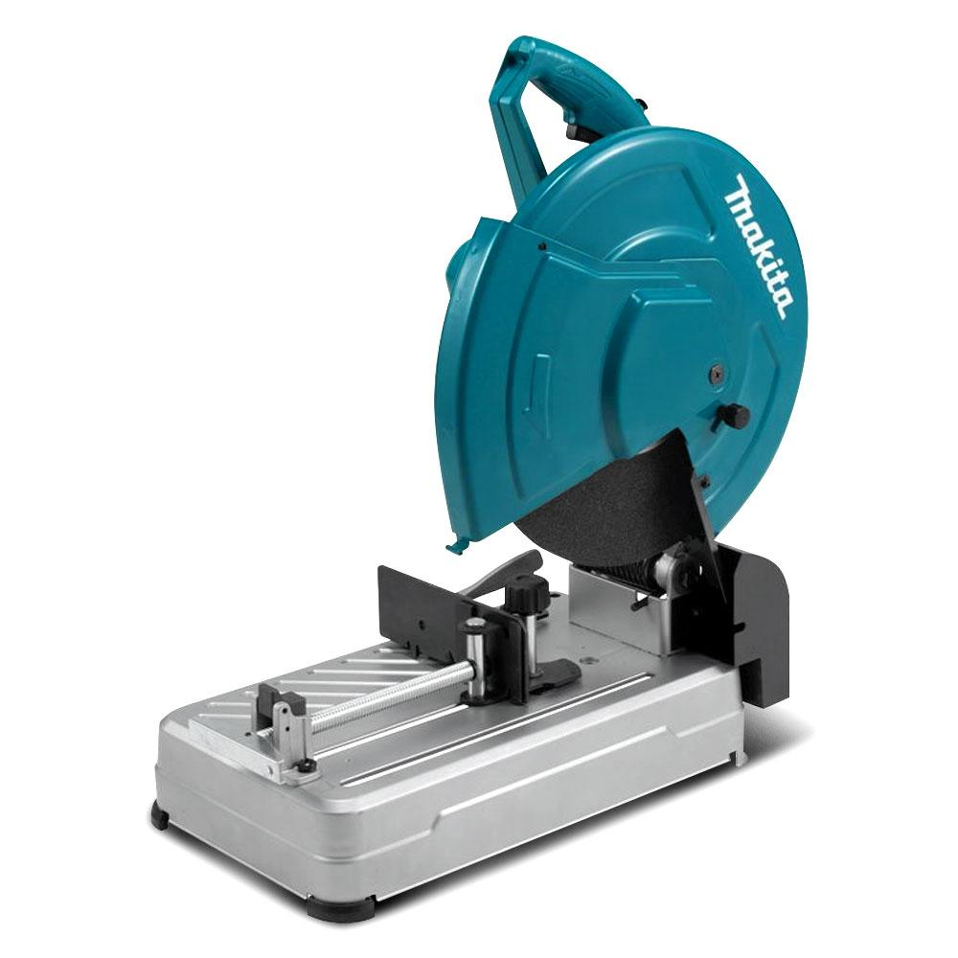

PRE-OPERATIONAL SAFETY
- Ensure the power tool has a suitable safe work area.
- If changing cut-off wheel, check for appropriateness and arbor hole size.
- Inspect the cut-off wheel for chips and cracks.
- Check that the guards are all in place and in good working order.
- If fitted with a depth stop, ensure that it is in proper adjustment/alignment.
- Familiarise yourself with the operation of the ON/OFF switch.
- Ensure your work area is clear of slip/trip hazards and flammable materials.

OPERATIONAL SAFETY PRECAUTIONS
- Ensure all adjustments to the machine are secure before making a cut.
- Do not hold your work piece by hand. It may become very hot while being cut.
- Use the vice to clamp the work and properly support any overhanging portion so the work piece is level with the base of the machine.
- Do not use a length stop on the free off-cut end of a clamped work piece.
- Allow the machine to reach full speed before contacting the work piece.
- Do not have any part of your body in line with the path of the abrasive disc.
- Ease the abrasive disc against the work piece when starting. Do not force tool.
- Keep hands away from cutting. Do not attempt to remove cut material while the abrasive wheel is moving.
- After finishing the cut, release the switch, hold the saw arm down and wait for the disc to stop before removing your work piece or off-cut piece.
- Before making any machinery adjustments, bring the machine to a complete standstill, and then disconnect the AC plug from the power source.

HOUSEKEEPING
- Ensure ventilation openings and switches are kept clean and free of foreign matter.
- Leave the work area in a safe, clean and tidy condition.

Date of last review: |  |  |  | Signature:

