Electric Bed |  |  |  |  |  | SOP Number: | RA Number:
 |  |  |  |  |  | 036SOP | 014RA
DO NOT use / operate / this equipment or complete the task unless you have been trained.
POTENTIAL RISKS: Crushing injuries; Sprains / Strains; Electric Shock;
 |  |  |  |  | 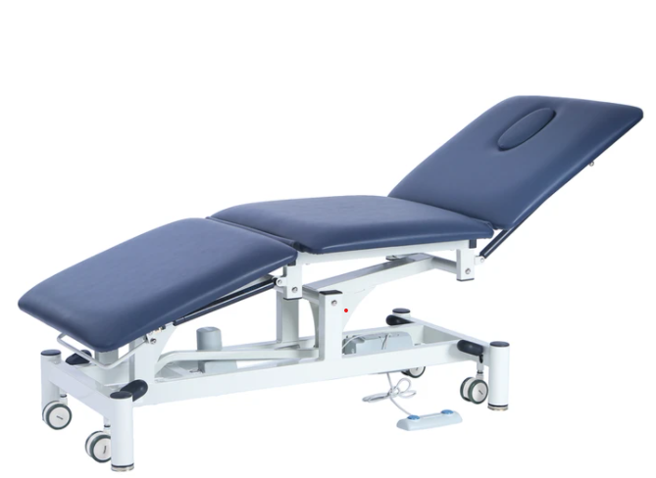

PRE-OPERATIONAL SAFETY
Complete a pre-start inspection of the equipment, this includes:
- Ensure cord is away from any entrapment points
- Check that the cord is not damaged and has been tested with current tag affixed.
- Before moving the bed, ensure person is safely on the bed

OPERATIONAL SAFETY CHECKS
- Check that all external cables are connected
- Familiarise yourself with the control pad
- Ensure all brakes have been applied to the wheels before attending resident.
- To raise and/or lower head of bed extend winder - right hand side of foot end of bed.
- To raise and/or lower height of bed extend winder – middle of foot end of bed.
- Position body correctly either by squatting or lunging to use winder.
- When cleaning room ensure bed repositioned correctly and brakes re-applied to all wheels.
- Use control pad to achieve desired settings

HOUSEKEEPING
- Ensure control placed back in correct completed.
- Do not leave extended
- Report any issues.

Date of last review: |  |  |  | Signature:

Acknowledgement much of the information in this document has been sourced by the Department of Education & Children’s Services SA.

