FORKLIFTS |  |  |  |  |  | SOP Number: |  | RA Number:
 |  |  |  |  |  | 084SOP |  | 090RA
DO NOT use / operate / this equipment or complete the task unless you have been trained.
POTENTIAL RISKS: Tip overs, Collisions, Overloading, Pedestrians, Unstable ground, Overhead Obstructions, Combustibility due to gases, Poorly maintained forklift / attachments.
 | 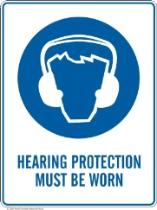 | 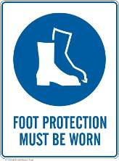 |  |  |  |  | 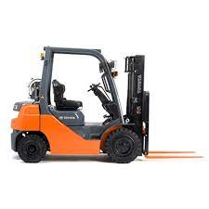

PRE-OPERATIONAL SAFETY
- Locate and ensure you are familiar with all machine operations and controls.
- Check brakes, lights and horn before use.
- Ensure reversing beeper and warning lights are operational.
- Ensure seat belt/safety restraint is in good condition.
- Know the capacity of the forklift before using it. Do not use a forklift without a load rating plate.
- Check gas-powered vehicles for gas leaks in fuel lines.
- Ensure the lifting forks are in sound condition and centred either side of the mast.
- Check tyre pressures. Never drive with a flat or under-inflated tyre.

OPERATIONAL SAFETY PRECAUTIONS
- Watch out for pedestrians.
- Ensure the lifting tines are secure into the pallet and the load is stable before lifting or driving off.
- Be careful of ceiling clearance or overhead obstructions when raising the mast.
- Always remember that the safe working load of a forklift reduces as the mast is tilted forward.
- Always put the heavy end of the load against the load backrest.
- When approaching a blind corner, use horn and drive slowly.
- Always have someone guide you if a load restricts your vision.
- Slow down when changing direction or on wet or greasy surfaces.
- Avoid harsh braking, especially when carrying a load.

HOUSEKEEPING
- When stopping the forklift:
- Park on even ground and lower the forks to the ground.
- Shift the gear selector to park position and apply the parking brake.
- Turn off the ignition and remove the keys.
- For gas-powered vehicles, turn off gas and don’t park near an ignition source, doorway or pit.
REFUELLING
- For gas-powered vehicles, change gas bottles in a well-ventilated area clear of a naked flame or source of ignition.
- For battery-operated vehicles, charge in well-ventilated area.
Date of last review: |  |  |  | Signature:

Acknowledgement much of the information in this document has been sourced by the Department of Education & Children’s Services SA.

