Gas Barbeque |  |  |  | SOP Number: | RA Number:
 |  |  |  | 029SOP | 016RA
DO NOT use / operate this equipment or complete the task unless you have been trained.
POTENTIAL RISKS: Fire, Hazardous Chemicals, Hazardous Manual Tasks, Extreme Temperatures
 |  |  | 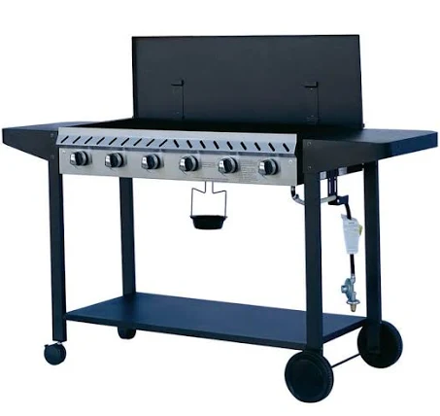  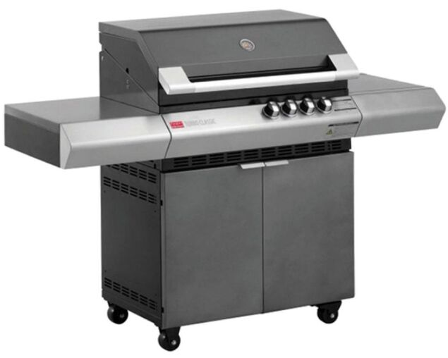

PRE-OPERATIONAL SAFETY
- Ensure you are wearing the correct Personal Protective Equipment (PPE) for the task.
- Barbeque only to be used outdoors in a well ventilated area.
- Check gas bottle and barbeque for any leaks, faults or damage. Report any hazards to your Supervisor or Manager immediately.
- Gas Cylinders to be secured from movement and date stamped within ten (10) years.
- Fire Extinguisher to be available or water hose

OPERATIONAL SAFETY PRECAUTIONS
- Complete a visual inspection of the barbeque, looking for damage and gas leakage by spraying soapy water along the gas line and gas connections. If bubbling occurs tighten connections.
- Make sure that the gas is turned on at the cylinder and that the hood and / or burner lid is up.
- If fitted with a gas safety gauge, depress the button to allow gas to flow.
- Push the on knob in and turn anticlockwise to the high position hold the knob in until the burner ignites.
- Adjust the knob to high medium or low for the desired flame / temperature.
- Use tongs to move food on the barbeque.
- To turn off the barbeque turn off at the cylinder first and allow all gas left in the hose to burn off. Then turn the knob to off.
- Clean the barbeque when the plates are fully cooled down.

HOUSEKEEPING
- Remove all litter from the area and ensure all equipment is clean.
- When cleaning the barbeque, ensure that it has cooled sufficiently so that there is no risk of burns.
- Disconnect and wipe the grease collection pipe / container / tray.
- Remove any spills from the floor mat using a cloth or a mop if one is available.
- Return barbeque to the designated area for storage.
Date of last review: |  |  | Signature:

Acknowledgement much of the information in this document has been sourced by the Department of Education & Children’s Services SA.

