Generator |  |  |  |  |  | SOP Number: |  | RA Number:
 |  |  |  |  |  | 055SOP |  | 052RA
DO NOT use / operate / this equipment or complete the task unless you have been trained.
POTENTIAL RISKS: Rotating and moving parts; Electric Shock; Noise; Exhaust fumes
Burns

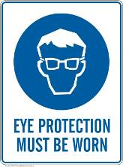 | 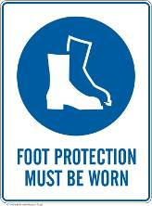 | 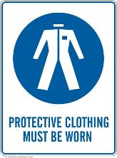 | 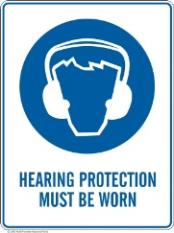 |  |  |  | 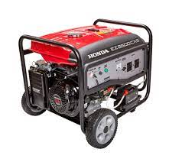

PRE-OPERATIONAL SAFETY
Two people as a minimum are to lift the generator
Ensure generator is on a firm and level surface at a
short distance from the work area Ensure generator is adequately earthed
Wear eye protection and gloves when refuelling
Ensure generator output is sufficient to power the necessary equipment or electrical circuit
Check to make sure that generator has been certified and tagged by an electrician that the certification is current
Check residual current device (RCD) and overload breaker switches are operational
Where an RCD is not fitted, a portable RCD must be used

OPERATIONAL SAFETY PRECAUTIONS
When starting adopt a tripod stance, do not twist your
body and do not pull cord past your body
Only use generators outdoors in well ventilated areas
Ensure no smoking, naked flames or ignition source
Carry fuel in approved clearly marked containers only
Ensure fuel cap secure
Use funnels and/or spout and take care not to spill on hot parts
Allow generator to cool down before refuelling

HOUSEKEEPING
1. Switch off and the machine. Leave the machine in a safe, clean and tidy state

Date of last review: |  |  |  | Signature:

