Grinder (Bench) |  |  |  |  |  | SOP Number: | RA Number:
 |  |  |  |  |  | 043SOP | 088RA
DO NOT use / operate / this equipment or complete the task unless you have been trained.
POTENTIAL RISKS: Rotating and sharp parts; Electricity; Noise; Pinch and squash Dust and fumes; Eye injuries; Burns and hot ejected waste material

 |  |  |  |  |   Rings & jewelly must not be worn | 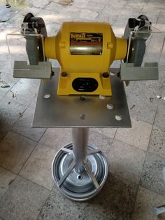

PRE-OPERATIONAL SAFETY
- Check workspaces and walkways to ensure no slip/trip hazards are present.
- Ensure all guards and safety shields are in position before starting the grinder.
- Ensure that the wheels do not touch the work rest and that the gap between wheel and rest is no greater than 1.5mm.
- Check that wheels are running true and are not glazed or loaded.
- Locate and ensure you are familiar with the operation of the ON/OFF starter.
- Faulty equipment must not be used. Immediately report any suspect machinery.

OPERATIONAL SAFETY CHECKS
- Stand to the side of the wheels when starting up.
- Let the wheels gain maximum speed before starting to grind.
- Do not grind on the side of the wheel.
- Small objects must not be held by hand.
- Never leave the machine running unattended.
- Do not bend down near the machine whilst it is running.
- Never force the work-piece against a wheel.
- Slowly move the work-piece across the face of the wheel in a uniform manner.
- Coolant spilt on the floor should be immediately absorbed.

HOUSEKEEPING
- Switch off the grinder.
- Leave the machine in a safe, clean and tidy state.

Date of last review: |  |  |  | Signature:

Acknowledgement much of the information in this document has been sourced by the Department of Education & Children’s Services SA.

