Hedge Trimmer - Electric |  |  |  |  |  | SOP Number: |  | RA Number:
 |  |  |  |  |  | 028SOP |  | 053RA
DO NOT use / operate this equipment or complete the task unless you have been trained.
POTENTIAL RISKS: Mechanical, Hazardous Chemicals, Hazardous Manual Tasks, Gravity, Noise
 | 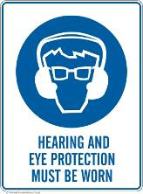 |  | 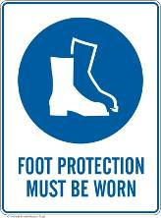 |  |  |  | 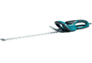

PRE-OPERATIONAL SAFETY
- Check for obvious faults and defects including electric cord (if not battery powered) for signs of wear or damage.
- Equipment has current test and tag (if not battery powered).
- Identify ON/OFF switch/s.
- Wear appropriate PPE.

OPERATIONAL SAFETY PRECAUTIONS
- Transport the machine with the scabbard on and the blade facing away from you.
- Hold trimmer firmly with both hands.
- Ensure firm footing.
- If excessive dust is present use an appropriate respirator.
- Move your body with the trimmer; do not twist from the waist.
- Keep cord free from cutting blades at all times (if fitted)
- DO NOT cut over shoulder height.
- DO NOT walk with trimmer whilst blades are moving
- DO NOT use in the rain or wet conditions.
- Ensure bystanders are at least 5 metres away from your working position.
- If using the machine for prolonged periods take breaks to avoid tiredness and fatigue.

HOUSEKEEPING
- Ensure cutters have stopped before removing waste material
- Ensure cutters have stopped before placing trimmer on the ground.
- Clean the cutting blade with a resin solvent.
- Ensure equipment is returned to storage after use and safely stored.
Date of last review: |  |  |  | Signature:

Acknowledgement much of the information in this document has been sourced by the Department of Education & Children’s Services SA.

