High Pressure Cleaner |  |  |  |  |  | SOP Number: | RA Number:
 |  |  |  |  |  | 032SOP | 096RA
DO NOT use / operate / this equipment or complete the task unless you have been trained.
POTENTIAL RISKS: Sprains / Strains; Electric Shock; Slip / Trip / Fall; Burn; Bruising
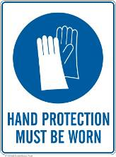 | 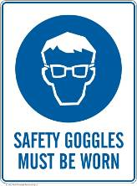 | 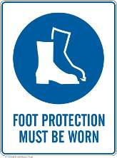 | 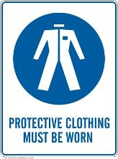 |  | 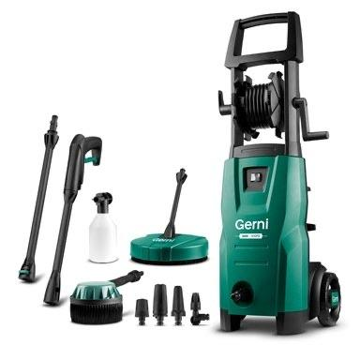

PRE-OPERATIONAL SAFETY
- Check all parts and cords for any damage before use.
- Unwind high pressure hose fully from the hose drum.
- Use only attachments supplied and approved by the manufacturer.
- Wear appropriate PPE.

OPERATIONAL SAFETY PRECAUTIONS
- The high pressure cleaner must not be directed at other people, animals or live electrical equipment.
- Sweep or brush all loose dirt and debris from the surface you are about to clean.
- Once all equipment is in position, connect to a water supply and ensure safety signs are on display
- Check the hoses are free of clogs and kinks and start up pressure washer.
- Start from a designated work area (building side) working outward when cleaning outside.
- Hold pressure washer wand with both hands and work the wand from shoulder to shoulder, slowly moving forwards.
- Do not swing the wand side to side in fast and erratic movements.
- Ensure firm footing and hold the spray handgun and spray lance firmly in both hands whilst in operation.

HOUSEKEEPING
- Turn off appliance and press the lever to release any remaining pressure in the system.
- Disconnect the appliance from water supply
- Store the handgun and spray lance in the accessory point and store appropriately
Date of last review: |  |  |  | Signature:

Acknowledgement much of the information in this document has been sourced by the Department of Education & Children’s Services SA.

