Hoists (Patient) |  |  |  |  |  | SOP Number: | RA Number:
 |  |  |  |  |  | 034SOP | 098RA
DO NOT use / operate / this equipment or complete the task unless you have been trained.
POTENTIAL RISKS: Sprains / Strains; Crush; Electric Shock; Fractures; Infection; Lacerations
 | 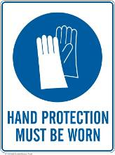 |  |  |  | 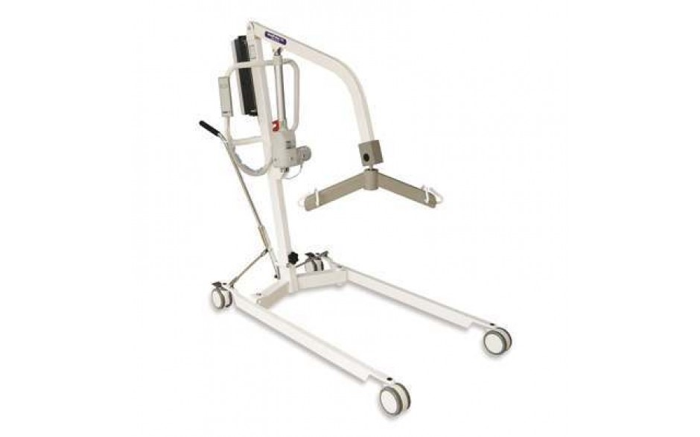

PRE-OPERATIONAL SAFETY
- Selection of the wrong size sling can result in discomfort & risk of falling

OPERATIONAL SAFETY CHECKS
Instruction
- Check the weight of the patient - it’s important that the patient’s weight doesn’t exceed the weight capacity of the hoist in use. Each hoist and its documentation will specify its weight capacity.
- Clear the environment of obstacles - Clear the floorspace and ensure that there is enough free room for the hoist and patient to manoeuvre.
- Check the hoist before use; it is important that carers handling the hoist ensure that everything is working correctly. It’s recommended that hoists receive maintenance checks, with a guidance of doing so every 6 months.
- Choose the right sling - Select a sling based on the patient’s size and weight.
- Assist the patient onto the sling - Once all of the necessary safety checks and precautions have been carried out, the patient can be safely assisted onto the sling. If the patient is being moved from a bed, carers need to move the patient safely onto the sling. To do so, carers should help a patient to safely roll onto their side. Whilst one carer supports the patient in this position, another carer should place the sling along the back of the patient so that they can roll back onto it, making sure that the sling is correctly lined up. Once complete, carers should gently roll the patient back onto their back, before rolling them onto their opposing side to repeat the same process. Take care with ensuring that the sling is properly lined up and spread out so that the patient is fully supported.
- Attach the sling to the hoist - Once the patient and sling are ready, prep the hoist so that it’s ready for the sling to be attached to it. When doing so, it’s imperative that carers comply with the instructions supplied with the specific sling and hoist in use, ensuring that the sling and attachments are properly fitted. Before lifting the sling, double-check that the attachments are secure.
- Begin lifting - Once the patient and sling are securely attached to the hoist, gently begin lifting the patient so that they are hovering above the surface they are being lifted from.
- Never leave the patient unattended - Once a patient is in the hoist and being lifted, never leave them on their own. Carers should accompany the patient at all times.
- Avoid long distances - Mobile hoists shouldn’t be used to travel patients for extended periods of time. If patients do need to go further, wheelchairs or ceiling hoists are recommended.
- Cleaning – Clean the hoist / sling after each use and store the mobile hoist in an area they can be charged if required.
Date of last review: |  |  |  | Signature:

Acknowledgement much of the information in this document has been sourced by the Department of Education & Children’s Services SA.

