Lathe Metal |  |  |  |  |  | SOP Number: |  | RA Number:
 |  |  |  |  |  | 059SOP |  | 060RA
DO NOT use / operate / this equipment or complete the task unless you have been trained.
POTENTIAL RISKS: Flying objects - chuck key left in chuck; Rotating machine parts – entanglement; Eye injuries; Metal splinters/swarf; Cutting tool injury when cleaning, filing or polishing

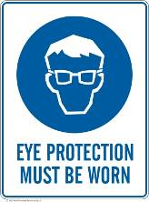 | 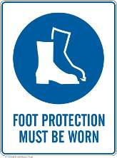 | 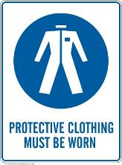 | 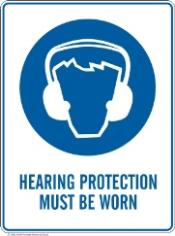 |  |  |  | 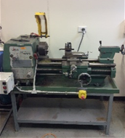

PRE-OPERATIONAL SAFETY
1. Check workspaces and walkways to ensure no slip/trip hazards are present.
2. Locate and ensure you are familiar with the operation of the ON/OFF starter and E-Stop.
3. Ensure all guards are in place.
4. Check that the job is clamped tight in the chuck.
5. Remove all tools from the bed and slides of the machine.
6. Ensure correct speed for machining process is selected.
7. Remove the chuck key before starting the lathe.
8. Do not try to lift chucks or face plates that are too heavy for you.
9. Faulty equipment must not be used. Immediately report suspect machinery.

OPERATIONAL SAFETY PRECAUTIONS
1. Never leave the lathe running unattended.
2. Before making adjustments or measurements switch off and bring the machine to a complete standstill.
3. Do not attempt to slow/stop the chuck or revolving work by hand.
4. Avoid letting swarf build up on the tool or job. Stop the machine and remove it.
5. Always remove the chuck key from the chuck.
6. Do not store tools and parts on top of the machine.

HOUSEKEEPING
1. Switch off the machine.
2. Leave the machine in a safe, clean and tidy state.
Date of last review: |  |  |  | Signature:

