Lathe |  |  |  |  |  | SOP Number: |  | RA Number:
 |  |  |  |  |  | 057SOP |  | 058RA
DO NOT use / operate / this equipment or complete the task unless you have been trained.
POTENTIAL RISKS: Eye injuries from flying debris or defective timber; Hair/clothing getting caught in moving machine parts; Airborne dust.
 | 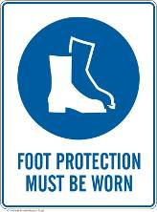 | 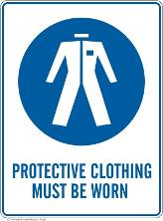 |  |  |  |  | 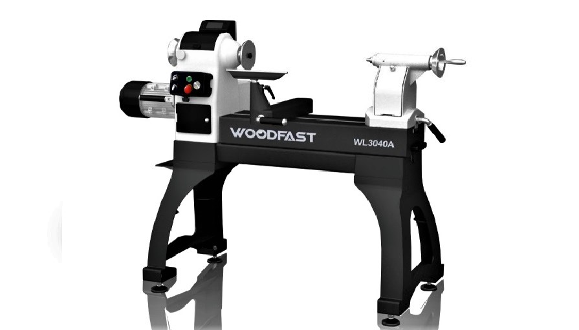

PRE-OPERATIONAL SAFETY
- Locate and ensure you are familiar with all machine operations and controls.
- Ensure all guards are fitted, secure and functional. Do not operate if guards are missing or faulty.
- Check workspaces and walkways to ensure no slip/trip hazards are present.
- Ensure the workpiece has been suitably prepared for the lathe operation.
- Workpiece must be securely fastened to face plate, chuck or between centres.
- Adjust speed to suit the diameter of the work and turning operation.
- Rotate the workpiece by hand to check clearance between tool rest and bed.
- Ensure the cutting tools are sharp and in good condition.
- Start the dust extraction unit before using the machine.

OPERATIONAL SAFETY PRECAUTIONS
- Locate and ensure you are familiar with all machine operations and controls.
- Ensure all guards are fitted, secure and functional. Do not operate if guards are missing or faulty.
- Check workspaces and walkways to ensure no slip/trip hazards are present.
- Ensure the workpiece has been suitably prepared for the lathe operation.
- Workpiece must be securely fastened to face plate, chuck or between centres.
- Adjust speed to suit the diameter of the work and turning operation.
- Rotate the workpiece by hand to check clearance between tool rest and bed.
- Ensure the cutting tools are sharp and in good condition.
- Start the dust extraction unit before using the machine.

HOUSEKEEPING
- Switch off the machine when work completed.
- Return all chisels and other tools to racks.
- Remove all tool-rests and place in rack.
- Leave the machine in a safe, clean and tidy state.

Date of last review: |  |  |  | Signature:

