Metal Guillotine |  |  |  |  |  | SOP Number: |  | RA Number:
 |  |  |  |  |  | 058SOP |  | 059RA
DO NOT use / operate / this equipment or complete the task unless you have been trained.
POTENTIAL RISKS: Crushing; Manual Handling; Cuts and abrasions; Sharp edges
 | 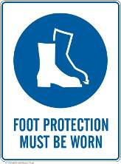 | 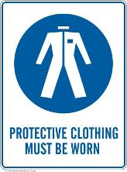 | 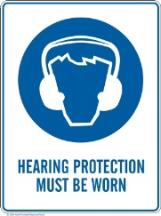 |  |  |  | 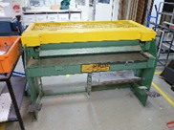

PRE-OPERATIONAL SAFETY
- Ensure fixed guards are in place to prevent hands or other parts of the body from entering the trapping space
- Guards or safety devices must never be removed or adjusted, except by an authorised person for maintenance purposes.
- Working parts should be well lubricated and free of rust and dirt.
- The area around the machine must be adequately lit and kept free of materials which might cause slips or trips.
- Be aware of other personnel in the immediate vicinity and ensure the area is clear before using equipment.
- Familiarise yourself with and check all machine operations and controls.
- Ensure cutting table is clear of scrap and tools
- Faulty equipment must not be used. Immediately report suspect machinery.
- Complete On Guard Safety Training and submit to Teacher.

OPERATIONAL SAFETY PRECAUTIONS
1. Do not attempt to cut material beyond the capacity of the machine.
2. Never attempt to cut rod, strap or wire with this machine.
3. Use correct lifting procedures when handling large sheets of material.
4. Take extreme care during the initial feeding of the work piece into the machine.
5. The work piece should always be held sufficiently far back from the edge being fed into the guillotine.
6. Ensure fingers and limbs are clear before actuating the guillotine.
7. Hold material firmly to prevent inaccurate cutting due to creep.
8. When cutting ensure feet are positioned to avoid contact with the foot operated lever.

HOUSEKEEPING
- Remove all off cuts and place them in either the storage rack or waste bin.
- Leave the machine in a safe, clean and tidy state.
Date of last review: |  |  |  | Signature:

