Mig Welding |  |  |  |  |  | SOP Number: | RA Number:
 |  |  |  |  |  | 047SOP | 043RA
DO NOT use / operate / this equipment or complete the task unless you have been trained.
POTENTIAL RISKS: Welding flash - eye injury; Burns; Electric Shock; fire; fumes
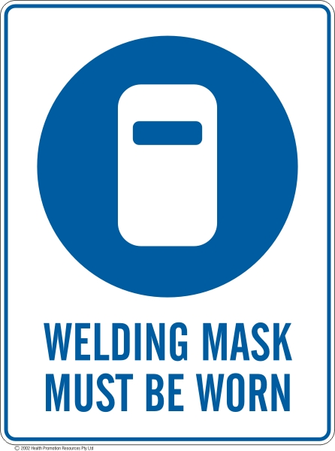 | 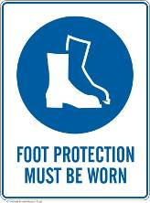 | 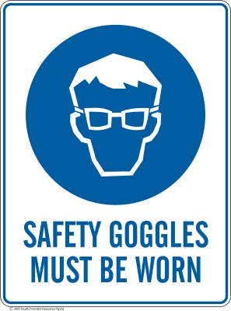 | 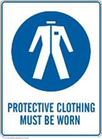 |  | 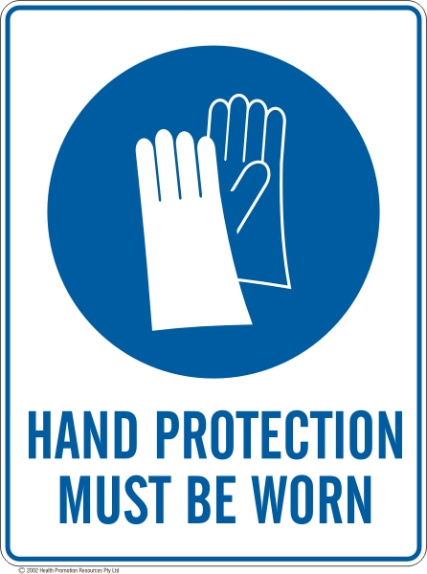 | 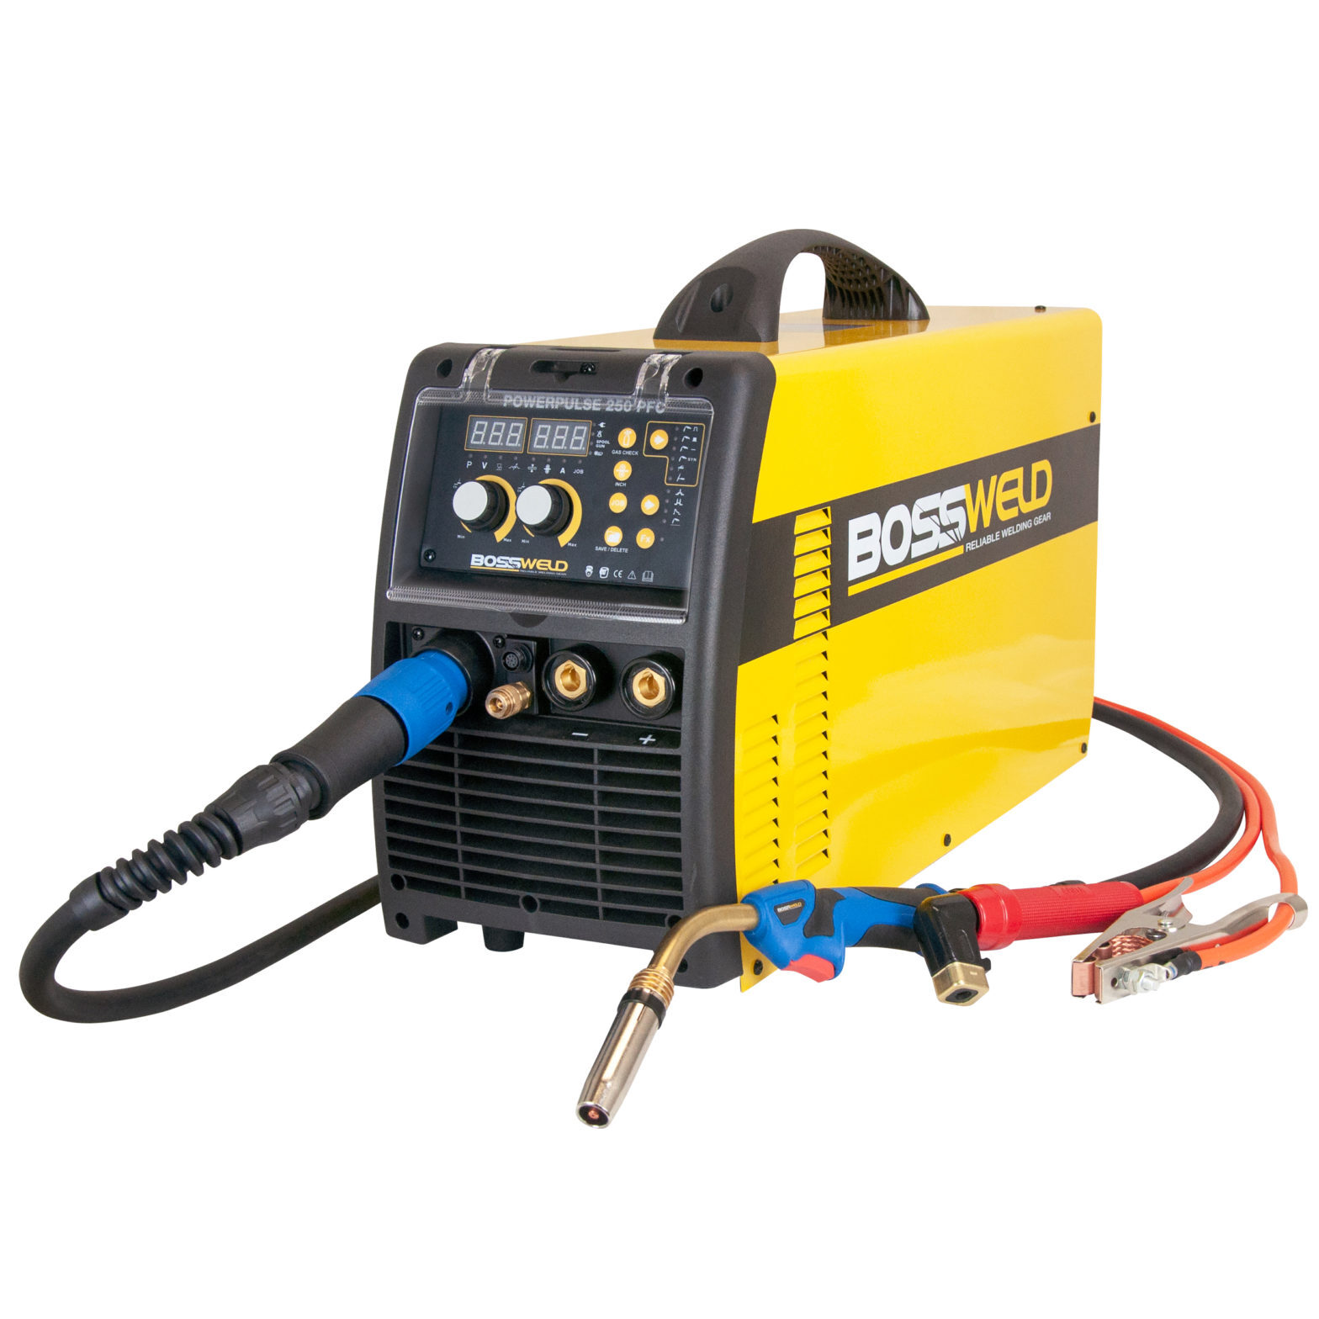

PRE-OPERATIONAL SAFETY
- Check workspace, walkways and work leads to ensure that no slip/trip hazards are present.
- Check work area is clean and free of grease, oil and flammable material.
- Ensure the equipment and work area is dry to avoid electric shocks.
- Check gloves, welding gun and work leads are in good condition.
- Ensure the fume extractor unit is on before welding commences.
- Close the UV curtain or erect safety screens to ensure the protection of others.

OPERATIONAL SAFETY CHECKS
- Ensure machine is correctly set up for current, voltage, wire feed and gas flow.
- Ensure work return cables make firm contact to provide a good electrical connection.
- Ensure the work piece has been prepared to be free of any paint, oxides, or other surface finishes ensuring a good electrical contact.
- Close curtains and ensure all bystanders are wearing proper PPE
- Never leave the welder running unattended.
- Avoid welding flashes. Erect UV safety curtains as required.
- Regularly inspect the welding tip and shield for damage.
- When welding is finished or interrupted, turn off the shielding gas at the regulator, turn off the machine and secure the handpiece.

HOUSEKEEPING
- Switch off the machine and fume extraction.
- Close gas cylinder valve.
- Hang up the welding gun and welding cables.
- Leave the work area in a safe, clean and tidy state.

Date of last review: |  |  |  | Signature:

Acknowledgement much of the information in this document has been sourced by the Department of Education & Children’s Services SA.

