Oxy/ Acetylene Welder |  |  |  |  | SOP Number: |  | RA Number:
 |  |  |  |  | 063SOP |  | 064RA
DO NOT use / operate / this equipment or complete the task unless you have been trained.
- POTENTIAL RISKS: Flying sparks; Fumes and vapours; Flashbacks
IR radiation burns to eyes and skin; Fire; Explosion by gas leakage

 | 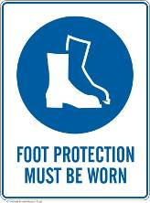 | 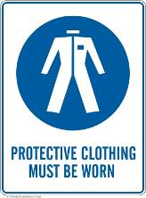 | 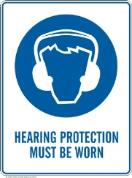 | 

PRE-OPERATIONAL SAFETY
1. Check workspace to ensure that no slip/trip hazards are present.
2. Check work area is clean and free of grease, oil and flammable material.
3. Ensure gas hoses are in good condition and are not causing a trip hazard.
4. Inspect all equipment for signs of damage.
5. Check for ventilation and ensure fume extraction unit is on.
6. Gloves should be used to position and hold work.

PRESSURE SETTING
1. Check the oxygen and acetylene/fuel regulator adjusting knobs are loose.
2. Check that both blowpipe valves are closed.
3. Slowly open the cylinder valves on each cylinder for half a turn only.
4. Screw in the regulator adjusting knobs slowly until the delivery pressure gauges register 70kPa.
5. Purge and check for constant oxygen gas flow.
- Open the oxygen blowpipe for two seconds valve and check the delivery gauge.
- If necessary, re-adjust the oxygen regulator to achieve a 70kPa pressure.
- Close the oxygen blowpipe valve.
6. Purge and check for constant acetylene/fuel gas flow.
- Open the acetylene/fuel blowpipe valve for two seconds and check the delivery gauge
- If necessary, re-adjust the acetylene regulator to achieve a 70kPa pressure.
- Check the acetylene blowpipe valve.

LIGHTING UP
1. Open the acetylene/fuel blowpipe valve slightly and light the blowpipe with a flint lighter.
2. Continue to slowly open the acetylene/fuel valve until the flame no longer produces soot.
3. Slowly open the oxygen blowpipe valve until a neutral flame is produced.

SHUTTING OFF THE BLOWPIPE
1. Close the acetylene/fuel blowpipe valve first.
2. Then close the oxygen blowpipe valve.

CLOSING DOWN
1. Close down both cylinder valves.
2. Open oxygen blowpipe valve to allow the gas to drain out.
3. When oxygen gauges read zero, unscrew regulator-adjusting knob.
4. Close oxygen blowpipe valve.
5. Turn off acetylene/fuel cylinder valve.
6. Open acetylene/fuel blowpipe valve and release gas.
7. When acetylene/fuel gauges read zero, release regulator-adjusting knob.
8. Close acetylene/fuel blowpipe valve.

HOUSEKEEPING
1. Hang up welding blowpipe and hoses.
2. Turn off fume extraction.
3. Leave the work area in a safe, clean and tidy condition.

Date of last review: | Signature:

