Pallet Jack - Handheld |  |  |  |  |  | SOP Number: |  | RA Number:
 |  |  |  |  |  | 089SOP |  | 102RA
DO NOT use / operate / this equipment or complete the task unless you have been trained.
POTENTIAL RISKS: Hydraulic fluid under pressure, Hazardous Manual Tasks – equipment & material, Slips, trips and falls, Heavy loads.
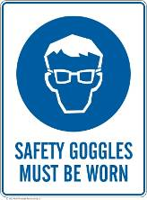 | 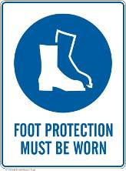 | 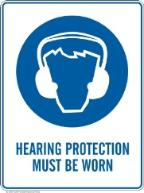 | 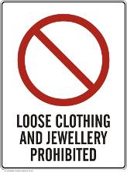 |  |  |  | 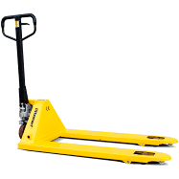

PRE-OPERATIONAL SAFETY
- Ensure your work area is well ventilated and not interfering with other students/activities.
- Visually check the condition of the trolley jack for damage.
- Check that the jack is labelled with a sticker indicating that it meets Australian standards – AS/NZS 2615.
- Familiarise yourself with the safe operation of this pneumatic trolley jack i.e. ensure you can safely raise and lower the jack.
- Ensure the floor surface you are rolling the jack on is hard, level and unobstructed.
- Familiarise yourself with the safe working limit of the trolley jack.

OPERATIONAL SAFETY PRECAUTIONS
- Ensure raised vehicles are supported with vehicle support stands.
- No person should get bodily under a vehicle supported by a hydraulic trolley jack.
- Read the vehicle manufacturer’s owner’s manual before lifting the vehicle.
- The wheels of the vehicle remaining on the ground should be chocked before the lifting operation proceeds.
- No person should be in the vehicle during the lifting process.
- The load should be centrally located on the head cap for the lift process.
- The trolley jack should be used to raise and lower only.
- Ensure that lubrication or other maintenance of the trolley jack is carried out according to the manufacturer’s instructions.

HOUSEKEEPING
- Leave the work area in a safe, clean and tidy condition.
- Ensure trolley wheels and jack handle are well maintained.

Date of last review: |  |  |  | Signature:

Acknowledgement much of the information in this document has been sourced by the Department of Education & Children’s Services SA.

