Pan Brake |  |  |  |  |  | SOP Number: |  | RA Number:
 |  |  |  |  |  | 064SOP |  | 065RA
DO NOT use / operate / this equipment or complete the task unless you have been trained.
POTENTIAL RISKS:
Sharp Edges and Burrs / Impact from Counterweight / Squash/crush and pinch points
 | 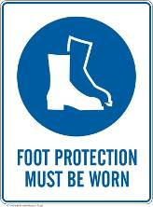 |  | 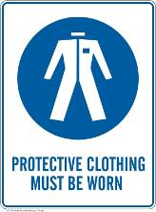 |  | 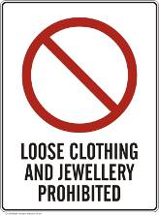 |  | 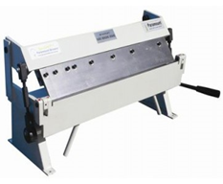

PRE-OPERATIONAL SAFETY
- Guards or safety devices shall never be removed or adjusted, except by an authorized person for maintenance purposes.
- Working parts should be well lubricated and the jaws and fingers free from rust and dirt.
- Ensure no slip/trip hazards are present in workspaces and walkways.
- Be aware of other personnel in the immediate vicinity and ensure the area is clear before using equipment.
- Familiarise yourself with and check all machine operations and controls.
- Faulty equipment must not be used.

OPERATIONAL SAFETY PRECAUTIONS
- Only one operator using the machine – school staff member to assist if required
- Never use pan brakes for bending metal that is beyond the machine’s capacity with respect to thickness, shape, or type.
- Never attempt to bend rod, wire, strap, or spring steel sheets in a pan brake.
- Remove the pan brake fingers that are in the way - use only the pan brake fingers required to make the bend.
- Ensure the pan brake fingers that are not removed for an operation are securely seated and firmly tightened before the machine is used.
- Ensure fingers and limbs are clear before operating the pan brake.
- Lower finger clamps to work - do not drop.
- Check work piece is secure & keep clear of moving counterweight (where fitted).

HOUSEKEEPING
- Lower finger clamps to a safe position - down position resting on base plate.
- Return all accessories to storage racks.
- Lock-out the action of the pan brake when not in use eg a system to lock handle & bending beam from use.
- Leave the work area in a safe, clean and tidy state.
Date of last review: |  |  |  | Signature:

Acknowledgement much of the information in this document has been sourced by the Department of Education & Children’s Services SA.

