Paper Shredder |  |  |  |  |  | SOP Number: | RA Number:
 |  |  |  |  |  | 066SOP | 067RA
DO NOT use / operate / this equipment or complete the task unless you have been trained.
POTENTIAL RISKS:
Electric shock / Cuts / Fumes
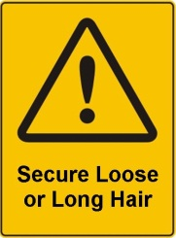 | 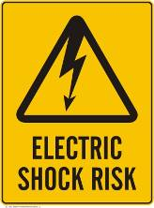 | 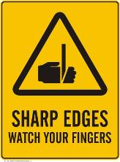 | 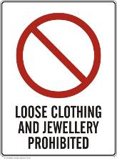 |  | 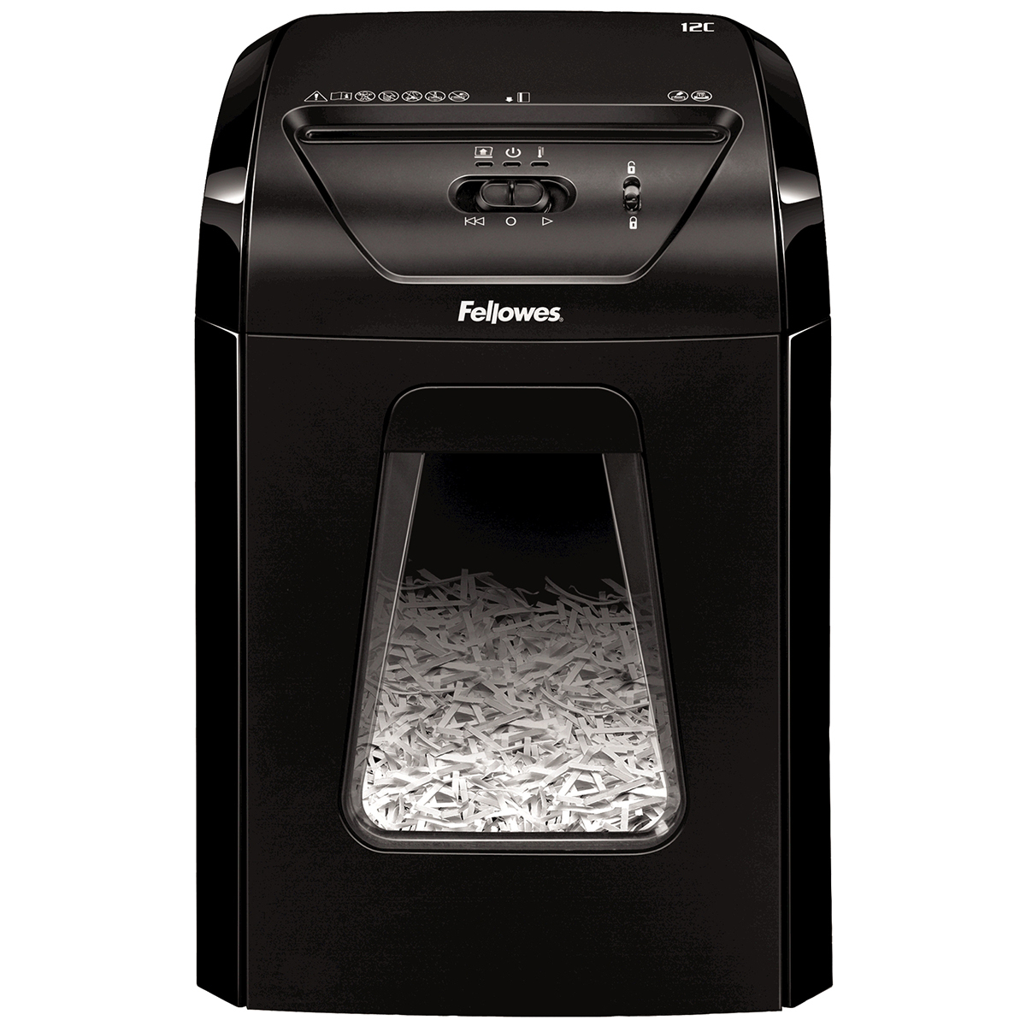

PRE-OPERATIONAL SAFETY
- Ensure to follow safety precautions in operators manual.
- Inspect shredder for damage.
- Inspect electrical cord / plug for damage.
- Ensure area is clear of obstructions / trip hazards.

OPERATIONAL SAFETY PRECAUTIONS
- Shredder should be clear of obstructions to allow sufficient air flow.
- Jewellery, long hair or loose clothing should be kept clear of shredder feed opening.
- Never put fingers or other objects other than paper into the shredder unless shredder is designed for such objects (compact disks).
- Never force paper into the shredder.
- Shred paper in quantities outlined in operators manual, do not exceed paper limit.
- Do not overheat shredder and allow to cool before each use.
- Ensure paper waste is removed regularly to prevent jamming.
- Always turn off and unplug when cleaning / emptying.

HOUSEKEEPING
- Ensure area is clear of trip hazards.
- Ensure area is kept in a clean and tidy manner.
- Ensure shredder is cleaned and maintained as per manufacturer’s requirements.
- Ensure paper is disposed of appropriately.
Date of last review: |  |  |  | Signature:

Acknowledgement much of the information in this document has been sourced by the Department of Education & Children’s Services SA.

