Polishing Machine (Buff) |  |  |  |  |  | SOP Number: |  | RA Number:
 |  |  |  |  |  | 069SOP |  | 072RA
DO NOT use / operate / this equipment or complete the task unless you have been trained.
POTENTIAL RISKS:
Work can be snatched if improperly presented to buff. Hair / clothing entanglement in moving machine parts / Eye injuries
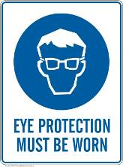 | 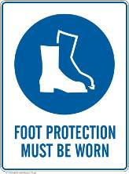 |  | 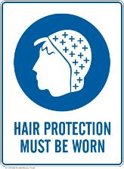 |  | 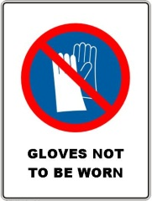 |  | 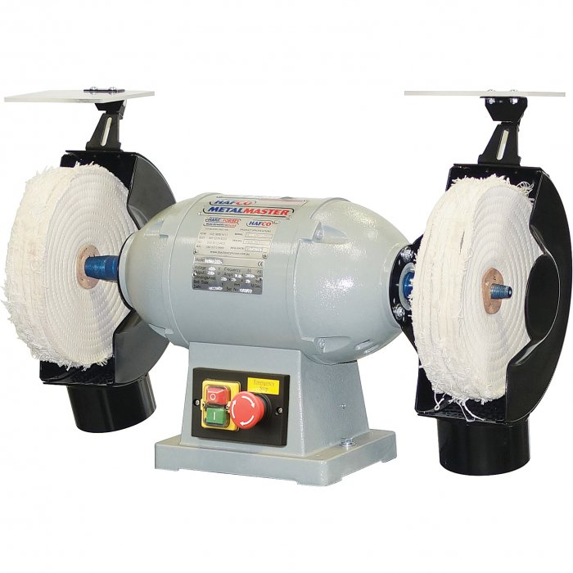

PRE-OPERATIONAL SAFETY
- Check workspaces and walkways to ensure no slip / trip hazards are present.
- Locate and ensure you are familiar with the operation of the ON / OFF starter.
- Both ends of the machine spindle must be covered at all times.
- Use appropriate mop type and polishing compound for the task.
- Faulty equipment must not be used.

OPERATIONAL SAFETY PRECAUTIONS
- Never leave the machine running unattended.
- Do not bend down near machine whilst it is running.
- Use the front of the wheel only.
- Work only below the centre of the spindle.
- Small work must be securely supported with a wooden backing.
- Work should be held so that edges cannot catch.

HOUSEKEEPING
- Switch off the machine.
- Leave the machine in a safe, clean and tidy state.
Date of last review: |  |  |  | Signature:

Acknowledgement much of the information in this document has been sourced by the Department of Education & Children’s Services SA.

