Pottery Kiln |  |  |  |  |  | SOP Number: |  | RA Number:
 |  |  |  |  |  | 070SOP |  | 073RA
DO NOT use / operate / this equipment or complete the task unless you have been trained.
POTENTIAL RISKS:
Burns from hot surface / Fumes / Material catching fire / Explosion / Sources of ignition from hot surfaces and work pieces
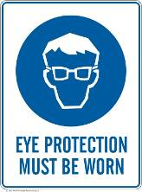 | 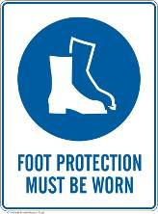 | 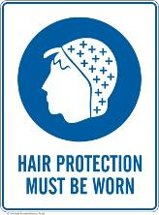 | 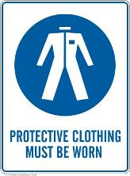 |  | 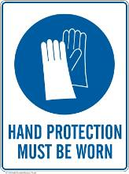 |  | 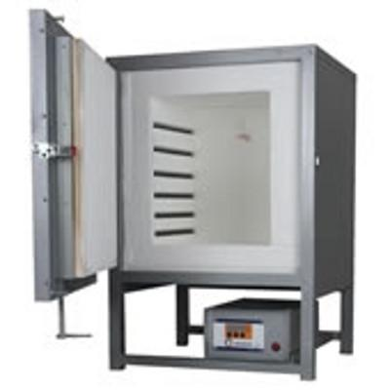

PRE-OPERATIONAL SAFETY
- Familiarise yourself with and check all kiln operations and controls.
- Kiln must not be used for any other purpose.
- Never heat a sealed container.
- Never heat any flammable or combustible liquid in the kiln.
- Ensure no slip / trip hazards are present in workspaces and walkways.
- Do not operate kiln if it is damaged.
- Ensure adequate ventilation.
- Ensure kiln is clear from other objects / items to prevent fires.

OPERATIONAL SAFETY PRECAUTIONS
- Maintain clearances for work pieces (not touching kiln wall).
- Spread the work pieces evenly throughout the kiln.
- Area must be clear of slip / trip hazards.
- Allow kiln to cool before reopening / removing work pieces.
- Before cleaning material accumulation, switch off and allow the kiln to cool completely.

HOUSEKEEPING
- Switch off the machine.
- Leave the machine in a safe, clean and tidy state.
Date of last review: |  |  |  | Signature:

Acknowledgement much of the information in this document has been sourced by the Department of Education & Children’s Services SA.

