Ride on Mower |  |  |  |  |  | SOP Number: | RA Number:
 |  |  |  |  |  | 035SOP | 104RA
DO NOT use / operate / this equipment or complete the task unless you have been trained.
POTENTIAL RISKS: Sprains / Strains; Fire; Sunburn; Stings / Bites; Lacerations; Eye Injuries; Striking
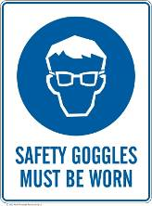 | 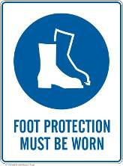 | 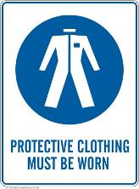 |  |  | 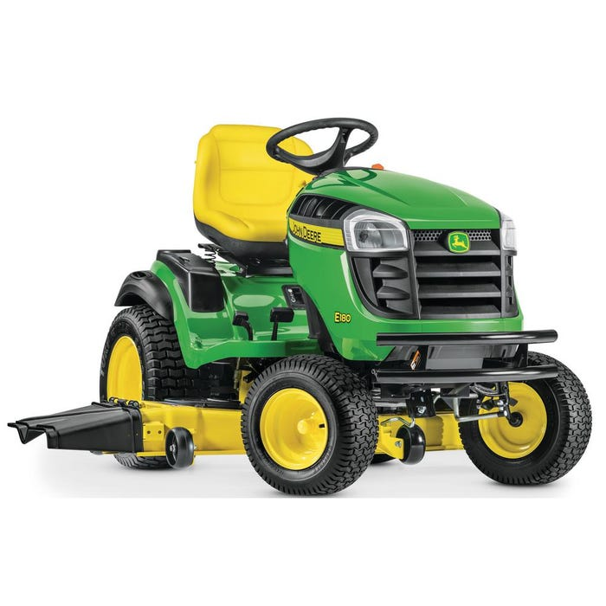

PRE-OPERATIONAL SAFETY
Complete a pre-start inspection of the equipment, this includes:
- Ensure all safety devices, guards, switches, and shields are fitted, secure and functional.
- Check oil levels and grease components as per manufactures specifications.
- Check Tyres are in good condition.
- When refuelling, ensure the motor is turned off, the area is free from any ignition sources (e.g. flame, sparks or cigarettes) and engine is cool (do not refuel when engine is warm/hot). Do not refuel in confined spaces due to the danger of inhaling fumes.
- Select the correct height adjustment for the cutting deck for the task.

OPERATIONAL SAFETY CHECKS
- Survey the area to be mowed and clear the area of any people and obstructions / hazards before commencing mowing.
- Ensure the transmission is out of gear and the mower blade clutch is disengaged before starting.
- If someone comes in close proximity to your work, stop and wait until they are a sufficient distance before recommencing mowing.
- Travel up/down slopes rather than across and use 15 degrees as the maximum to attempt to mow.

Stopping:
- Park on even ground and stop the mower.
- Shift the gear selector to park position and raise / secure the cutting blades.
- Lock the parking brake, Stop the engine and remove the keys.

HOUSEKEEPING
- Brush or blow down the mower after each use.
- Ensure that maintenance is scheduled and completed by a competent person

Date of last review: |  |  |  | Signature:

Acknowledgement much of the information in this document has been sourced by the Department of Education & Children’s Services SA.

