Scaffolding - Portable |  |  |  |  |  | SOP Number: |  | RA Number:
 |  |  |  |  |  | 072SOP |  | 075RA
DO NOT use / operate / this equipment or complete the task unless you have been trained.
POTENTIAL RISKS:
Collapse of scaffold / Incorrect assembly / Manual handling / Struck by falling objects / Slips/trips/falls / Noise / Exposure to weather / Sprains/strains / Electrocution
 |  | 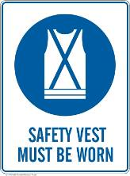 |  |  |  |  | 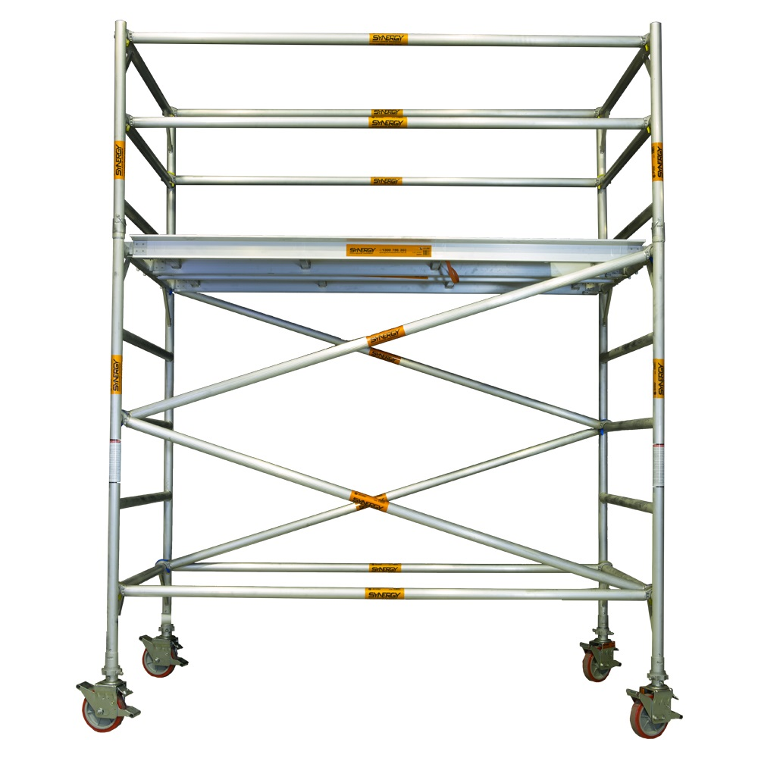

PRE-OPERATIONAL SAFETY
- Ensure all components are well-maintained. Do not use components that are in poor condition.
- Do not mix components from differently branded scaffolding systems.
- Read and follow the manufacturer’s specifications, assembly instructions and warning labels.
- Inspect scaffold before its first use and at the start of each day. Ensure scaffold remains level and plumb at all times
- Use barricades, danger tags or warning signs to prevent unauthorised access.
- Ensure edge protection (hand rails, mid-rails and toe boards) is provided.
- Wear appropriate personal protective equipment.
- Do not work during a storm, wet conditions or high winds.

OPERATIONAL SAFETY PRECAUTIONS
- Castor brakes are to be applied at all times while the mobile scaffold is stationary.
- Access is to be only by way of an internal ladder. No climbing is allowed on the scaffold itself.
- Only work on fully planked work platforms. Ensure that working platforms are kept clear of debris and obstructions along their length. Do not leave tools and equipment on scaffolds.
- Scaffold is not to be moved while workers are on the scaffold work platform.
- Limit the number of workers on a scaffold at any one time.
- Do not exceed the safe working load of the scaffold.
- Do not make any unauthorised alterations to the scaffold.
- Do not permit workers or other persons to stand directly below a scaffold.
- Do not drop materials from the platforms.
- Do not fix high voltage leads and cables to the scaffolding.
- Never use ladders or makeshift devices on top of scaffolds to increase height.

HOUSEKEEPING
- Check and maintain all scaffold parts. Repair or discard and replace any damaged pieces immediately.
- Lubricate moving parts of all fittings.
Date of last review: |  |  |  | Signature:

Acknowledgement much of the information in this document has been sourced by the Department of Education & Children’s Services SA.

