Sewing Machine |  |  |  |  | SOP Number: | RA Number:
 |  |  |  |  | 073SOP | 076RA
DO NOT use / operate / this equipment or complete the task unless you have been trained.
POTENTIAL RISKS:
Sharp Edges / Cuts and punctures / Eye Strain
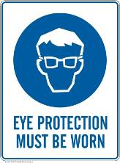 |  | 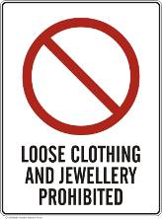 | 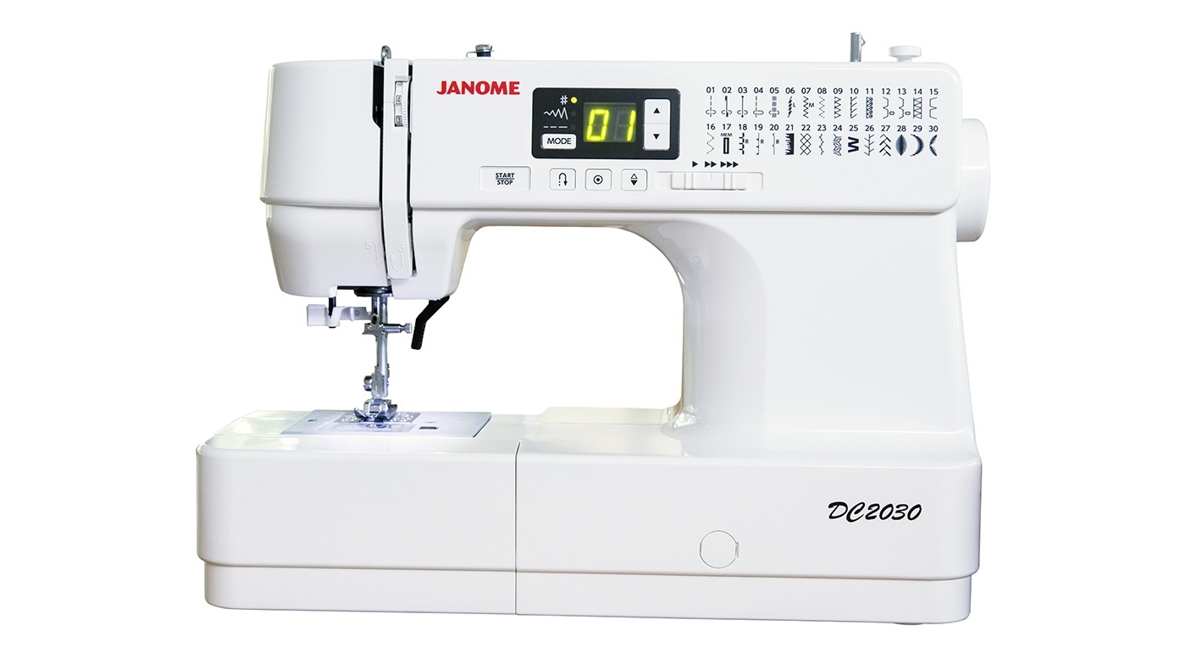

PRE-OPERATIONAL SAFETY
- Thoroughly review and understand information provided in the owner’s manual.
- Before using, always inspect for damage or disrepair, including power cord.
- Assure ventilation openings are clear of lint and scrap cloth.
- Inspect all machine settings and adjustments and modify as necessary for sewing task.
- Inspect the needle to make sure it’s not bent, dulled, or damaged. Never use a bent needle.
- If machine is damaged, do not use, until repairs have been made.

OPERATIONAL SAFETY PRECAUTIONS
- Only use a sewing machine for its intended purpose as described in the operator’s manual.
- Use the proper type and size needle for the fabric being sewn.
- For zig-zag or any other special stitching, use a throat plate that accommodates a wide stitch.
- Always maintain a safe zone, of about one inch, where fingers never enter when in operation.
- Learn to start and run machine slowly and evenly.
- Never sew across pins. Carefully use straight pins and when done, place in proper storage containers.
- Never look away from the machine while it is sewing. If you need to look away, stop sewing first.

HOUSEKEEPING
- Always turn the sewing machine off and unplug from the power source after use.
- Regularly clean the sewing machine with a lint brush after use.
- Clean up the work space when finished with your sewing task.
Date of last review: |  |  |  | Signature:

Acknowledgement much of the information in this document has been sourced by the Department of Education & Children’s Services SA.

