Thermomix |  |  |  | SOP Number: | RA Number:
 |  |  |  | 093SOP | 111RA
DO NOT use / operate / this equipment or complete the task unless you have been trained.
POTENTIAL RISKS: Burns / scalds; cuts / lacerations; electric shock
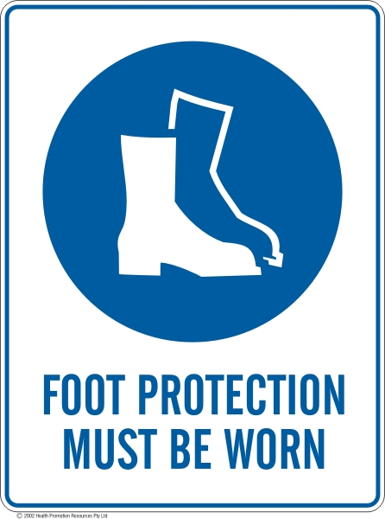 | 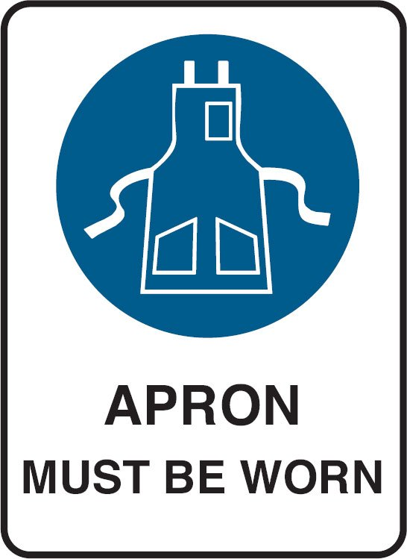 | 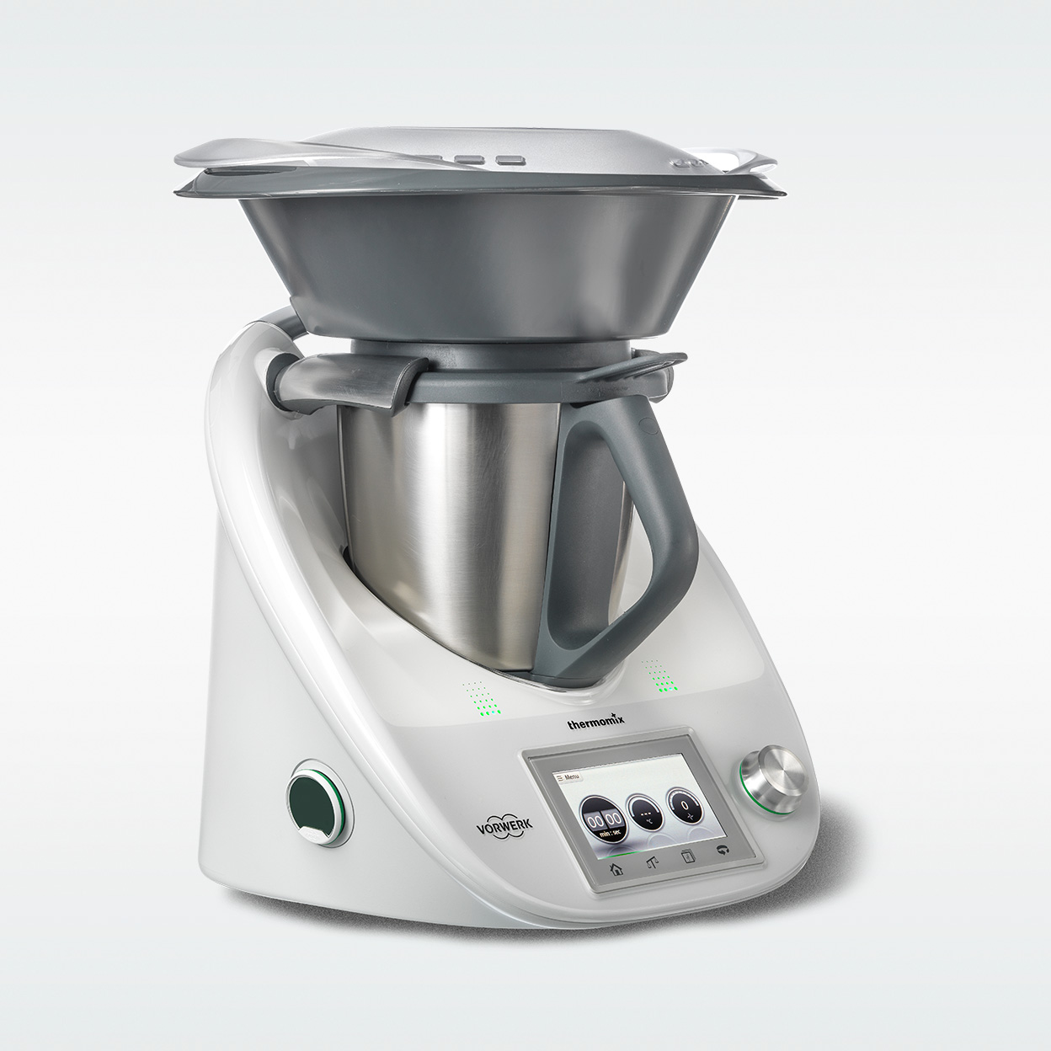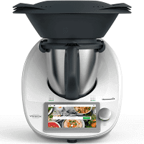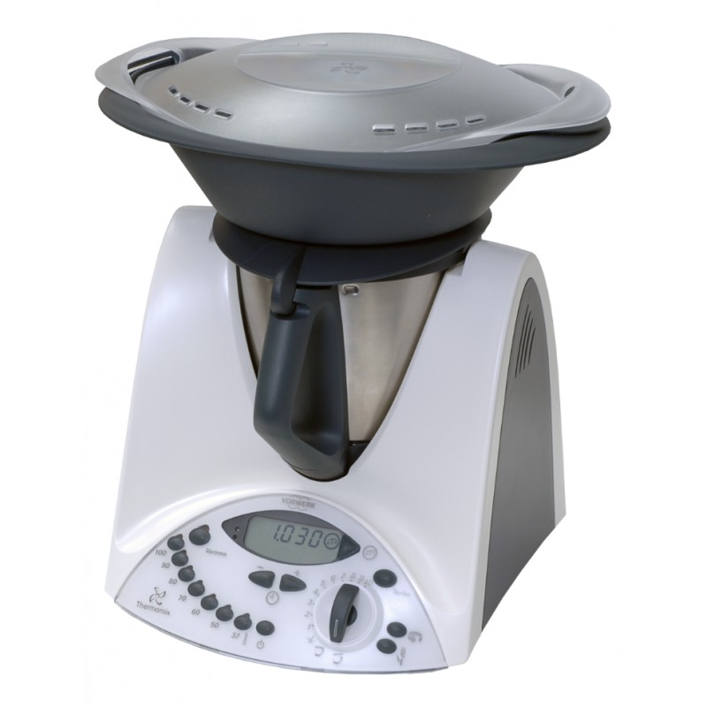

PRE-OPERATIONAL SAFETY
Refer to the applicable Instruction Manual for further information on safety.
TM5 Instruction Manual / TM6 Instruction Manual / TM31 Instruction Manual
- All electrical items are to be tested and tagged. Equipment that has not been tested or has not got a current test date is not to be used.
- Regular visual inspections are required to check that the equipment is free from obvious damage. Damaged equipment is not to be used.
- Electrical equipment is not to be used in an environment that is detrimental to the safe use of the equipment. Do not place the Thermomix near a water source or on top of a stove.
- Place on a dry, firm and stable bench.

OPERATIONAL SAFETY PRECAUTIONS
- When assembling the Thermomix bowl, hold the blade with a dry cloth and check the
blade is secure.
- When filling Thermomix, liquids must always be below the maximum indicator.
- When in use, do not hold down the lid.
- Food must be in small chunks, thumb size, to prevent the machine ‘walking’.
- Be aware that the mixing bowl will become hot, when using the cooking function. This will be indicated by flashing red lights on the machine.
- To allow steam to escape and prevent excess pressure, ensure that the hole in the mixing bowl lid is never blocked or covered when using the cooking / heating function
- Do not use the turbo mode for hot food or liquid over 60 °C. and do not abruptly increase the mixing speed when processing hot food. Increase the speed gradually.
- Take care when removing the lid to avoid steam burns
- Be aware of other people in the immediate vicinity when handling hot material.
- Spillages must be cleaned up immediately.
- Before cleaning, take apart carefully, this includes the lid seal and blade. Allow the mixing bowl and the mixing knife to cool sufficiently before dismantling the mixing bowl and removing the mixing knife.
- After cleaning, leave apart to air dry.
- DO NOT immerse the base unit in water to clean. Use a dry or damp cloth to wipe the base unit.

HOUSEKEEPING
- Thermomix is thoroughly cleaned prior to being reassembled.
- Only Thermomix approved parts / accessories are to be used.
Date of last review: |  |  | Signature:

Acknowledgement much of the information in this document has been sourced by the Department of Education & Children’s Services SA.

