Timber Planer |  |  |  |  |  | SOP Number: |  | RA Number:
 |  |  |  |  |  | 080SOP |  | 081RA
DO NOT use / operate / this equipment or complete the task unless you have been trained.

POTENTIAL RISKS: Cutting hands, Pinch and squash injuries, Flying chips and debris , Eye injuries, Excessive noise, Respiratory issues

 |  | 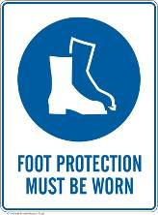 |  |  |  |  | 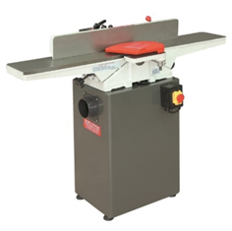

PRE-OPERATIONAL SAFETY
1. Check guards are in position and operational.
2. Locate and check the operation of the emergency stop.
3. Minimum length of material 300mm
4. Set depth of cut (maximum 3 millimetres) and lock table.
5. Check and lock fence in position.
6. One piece of material to be machined at a time.
7. Faulty equipment must not be used. Immediately report suspect machinery.
8. Do not attempt to plane end grain.

OPERATIONAL SAFETY PRECAUTIONS
- Never allow hands to pass over the cutter.
- Never leave the machine while it is still running.
- Wait for the machine to stop and isolate before making any adjustments.

HOUSEKEEPING
- Switch off the machine.
- Leave the machine in a safe, clean and tidy state.
- Reset the depth of the cut to 1mm or 0mm after use.
- Reset cutter block guards.
- Lockout machine.
- Sweep the machine down and remove all chips, shaving and wood dust.
FORBIDDEN
- Planing end grain.
- Planing timber 300mm or less in length.

Date of last review: |  |  |  | Signature:

Acknowledgement much of the information in this document has been sourced by the Department of Education & Children’s Services SA.

