Vibrating Plate Compactor |  |  |  |  |  | SOP Number: |  | RA Number:
 |  |  |  |  |  | 083SOP |  | 084RA
DO NOT use / operate / this equipment or complete the task unless you have been trained.
POTENTIAL RISKS: Manual handling injuries • Noise levels • Exhaust fumes • Vibrations • Hot engine components • Flammable fuel
 |  |  |  |  |  |  | 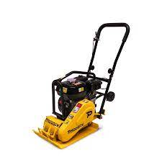

PRE-OPERATIONAL SAFETY
- Check compactors fuel level, oil level, air filter
- Check area for an potential obstacles or hazards
- Ensure that no flammable gasses or in the area
- Use assistance to lift the compactor
- Ensure the is not a confined space or a potential confined space
- Ensure you are wearing your PPCE
- Ensure that the machine has cooled before hosing down

OPERATIONAL SAFETY PRECAUTIONS
- Fuel compactor (if required) and remove fuel container back to store before starting
- Turn fuel on (lever down)
- Close choke and place throttle at idle
- Pull rope start in a smooth action, keeping knees bent and back straight
- Once started, open choke and allow to warm up
- Move throttle quickly to full position
- Let compactor plane along by itself, using the handles to steer the machine along.
- Bring the machine back to idle to stay stationary or when travelling over compacted or solid ground.
- Work progressively over the area to be compacted, to prevent the machine from ‘digging in’.
- Spray area with water to suppress dust and to aid with compaction.

HOUSEKEEPING
1. Allow compactor to idle for a few seconds before pressing the stop button.
2. Ensure the stop button is depressed until the motor is completely stopped
3. Once the motor has cooled the machine can be cleaned.
4. Place the machine in a secured area and back to store.
5. Report any fault

Date of last review: |  |  |  | Signature:

Acknowledgement much of the information in this document has been sourced by the Department of Education & Children’s Services SA.

