**Covid-19 Risk Assessment Guidelines**

[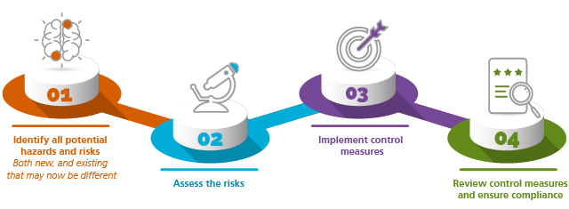](https://ecomms.sparke.com.au/collect/click.aspx?u=dGxVcFpxdjF0RGRjMkpOVFhIQUtBcmZPL2I2MHpUNHBWam1HK2VleldTdTIvQ1FFQTFhWU5qR0g4UmY2VGdtTlFwTmpaZzE2WnUwbW9ocmdud0VPL2VOOGhmSHp5R3R6NHY0QXZxUVhZN3dpRGhaT2xnODRrbEdZc1NvbVpTaWtnQmZmQW1jTU02Zz0=&rh=ff0061356c49143e5acbed900f44b8e0d2f6f4c9)

|  |  |
| --- | --- |
| **Identify all potential hazards and risks – both new and existing (which may have changed)** | |
| Identify all hazards and risks that might be present as workers begin to return to the physical workplace. Some potential hazards / risks may include: | |
| https://f.datasrvr.com/f1/120/97175/Icon_1.png | * COVID – 19 transmission within the workplace; * Confirmed positive COVID -19 cases within the workplace; * New operational risks due to process and system changes; * Maintenance of plant and equipment - have scheduled maintenance tasks been missed? * Licences and permits – are they still current and appropriate? * New starters – completing inductions, conducting training and providing supervision arrangements; * Security of confidential information as workers transition from home back to the physical workplace; * Ongoing mental health implications associated with isolation and possible overwork for those who continue to work from home; * Vulnerable workers – risk of discrimination, victimisation or general protections applications for those who continue to be at higher risk and prefer not to return to work; * Environmental risks – have risks to human health and the environment changed? |
| **Assess the risks** | |
| Conduct a comprehensive and rigorous risk assessment for all the risks identified in step 1. | |
| https://f.datasrvr.com/f1/320/96679/Icon_2.png | * For any newly identified or changed risks assess the nature of the harm that could be caused by the hazard / risk, how serious the harm could be and the likelihood of it happening. Some additional considerations may include:   + Are existing systems of work still appropriate or is the magnitude of a particular risk increased or changed because of process and system changes?   + Vulnerable workers – the risks may be different for older workers, or workers with underlying health conditions. |
| **Implement the controls** | |
| Identify and implement appropriate control measures for each hazard / risk identified and assessed in steps 1 and 2. Some considerations may include: | |
| https://f.datasrvr.com/f1/820/95373/Icon_3.png | * Rely heavily on Safe Work Australia’s information and resources, including the extensive industry specific guidance. Broadly for all workplaces this will involve:   + Maintaining working from home arrangements for workers were able to;   + Enforcing physical distancing within the physical workplace;   + Encouraging good hygiene practices;   + Ensuring workers that present even the most mild symptoms of respiratory illness are encouraged to be tested and are required to self-isolate at home until cleared; and   + Ensuring increased cleaning of common areas and frequently touched surfaces, including desks and work stations. * Consider additional bespoke control measure that relevant to your workplace; * Form non COVID -19 related hazards and risks:   + Apply the usual rigorous risk management approach, remembering that because so many variable have changed some existing control measures may no longer be appropriate;   + Consider whether there have been changes to relevant standards or general industry practice since the pandemic began. Have the reasonable practicable measures changed: What are competitors doing differently:   + Training needs analysis for the “new way of working”   + Are supervision arrangements appropriate give different mix of work locations? |
| **Review control measures and ensure compliance** | |
| To ensure implemented control measures remain effective, review and assess measures on a regular basis, including when the state COVID – 19 restrictions are changes. | |
| https://f.datasrvr.com/f1/620/55074/Icon_4.png | * Whether the control measures continue to be fit for purpose and effective; * Worker, contractor and visitor compliance with risk controls and potential complacency. If non-compliance emerges, appropriate actions must be taken from an employment / disciplinary or contractual perspective, or by excluding those who refuse to comply. |